SECTION-V (Bid and Contract Forms)
PART-A (Bid Forms and Attachments)

Sub-Part: A1
(Technical Proposal Submission Letter and Attachments)

IFB No.: BIFPCL/MSTPP/COAL/8.0 MMT/1146 Date: 12.03.2026

Name of Package: Procurement and Delivery of 8.0 MMT of Imported Coal at Plant Jetty (CDP) for 2x660MW Maitree Super Thermal Power Project at Rampal, District- Bagerhat, Bangladesh

To,
Chief Procurement Officer
Bangladesh-India Friendship Power Company (Pvt.) Limited.
Level-17, Borak Unique Heights
117, Kazi Nazrul Islam Avenue,
Eskaton Garden, Dhaka-1000,
Bangladesh

Sir,

Proposal No. ……………………………. Date: ………………………

- Having examined the Bidding Document(s) bearing no. BIFPCL/MSTPP/COAL/2026/01 , including subsequent amendments ............................. and clarifications............................. issued thereto, if any (insert numbers), the receipt of which is hereby acknowledged, we, [insert name of Bidder] (“Bidder”/ “we”/ “us”), acting through the undersigned, offer to provide the complete scope of work under the above-named package in full conformity with the said Bidding Document(s).

- Attachments to the Technical Proposal Submission Letter

In line with the requirement of the Bidding Document, we enclose herewith the following Attachments to the Technical Proposal Submission Letter:

- Attachment 1: Bid Security. Bid Security in the form of Bank Guarantee from .................................................... (Please fill in the details of the bank chosen), endorsed/confirmed by ………………………………………… (Please fill in the details of the bank / correspondent Bank in Bangladesh) for a sum of USD/BDT ................................................................. .............................. (amount in words & figures), valid for a period of 225 days from the date set for opening of Technical Proposal. As required, the Attachment-1 (i.e. Bid Security in original) has been furnished in a separate sealed envelope.

- Attachment 2: Power of Attorney. A power of attorney duly notarized by a Notary Public [along with copy of Board resolution (wherever applicable)], indicating that the person(s) signing the bid has/have the authority to sign the bid, having been authorised in this regard, and that the bid (Technical Proposal and Financial Proposal) is binding upon us during the full period of its validity in accordance with ITB Clause 5.9 read with Clause 5.10 (as may be extended), has been enclosed.
- Attachment 3: The documentary evidence in terms of IFB Clause 5.0, establishing that we are qualified to perform the Contract, in the event that our bid is accepted. The qualification data furnished has been enclosed as Attachment-3 herein. Moreover, we have also submitted the Deed of Joint Undertaking as Attachment - 3E (if applicable), and the Consortium Agreement as Attachment - 3F (if applicable), in accordance with the applicable provisions of the ITB.

- Attachment 4: Technical Solution and Data. The proposed Technical Solution and Data, guarantee figures, details of sub-contractors, and other relevant technical data, information, and supporting documents, in accordance with the ITB.

- Attachment 5: Certificate for Compliance to All Provisions of Bidding Document – Certificate of Compliance confirming that no deviation has been made by us, in Envelope-1 (Technical) Proposal and Envelope-2 (Financial) Proposal. This certificate is enclosed in a separate sealed envelope.

- Attachment 6: Certificate of Compliance to Environmental Impact Assessment Approval Conditions undertaking to comply with all the approval conditions of the Environmental Impact Assessment (“EIA”) for Coal Transportation for 2x660 MW Maitree Super Thermal Power Plant Project, as stipulated by the Department of Environment (DOE), Government of Bangladesh. This certificate is enclosed in a separate sealed envelope.

- Attachment 7: Other related information like Details of Management Capabilities and Compliance with Health, Safety, and Environment Quality Standards, Details of the present Assignment, and any other information in terms of the IFB.

- Such other attachments as required to be submitted with the Technical Proposal in accordance with the Bidding Document(s), are attached as below:

The various attachments for the Financial Proposal, as set forth under ITB Clause 5.3.3, have been submitted with the Financial Proposal in Envelope-2.

- Compliance with all provisions of the Bidding Document(s): We have read and understood all the provisions of the Bidding Document(s) and confirm that notwithstanding anything else that may have been stated elsewhere in our bid/ proposals to the contrary, all provisions of the Bidding Document(s) are acceptable to and binding on us, and we further confirm that we have not made any deviation from any of provisions of the Bidding Document(s).

We have furnished the “Certificate of Compliance to All Provisions of Bidding Document” and “Certificate of Compliance to Environmental Impact Assessment Approval Conditions”, as per the prescribed proforma in Attachment-5 and Attachment-6, in separate sealed envelopes. We further understand that in the absence of the above certificates as per Attachment-5 and Attachment-6 in separate sealed envelopes, our proposal shall be liable to be rejected.
3.1 We further declare that additional conditions, variations, deviations, if any, found anywhere in the proposal, save those pertaining to any rebates offered, shall not be required to be considered and given effect to.
- We agree to abide by this Technical Proposal for a period of 180 days from the date of opening of Technical Proposal as stipulated in Bidding Document(s), unless extended by us at your request in this regard, and it shall remain binding on us and may be accepted by you at any time before the expiration of the said period.
- We undertake, if our bid is accepted, to commence all the necessary actions immediately upon issuance of your Letter of Intent (LOI) / Notification of Award (NOA), and shall arrange all the required facilities and conduct the Demonstration as suggested in terms of Clause 7.0 of Technical Specification, Section-IV within the timeline specified in the Bidding Document(s).

  - If our bid/ Proposal is accepted, we undertake to provide Performance Security and other securities (as applicable), and other submissions in the form (and amounts, where applicable) within the timelines specified in the Bidding Document(s).

- Until a formal Contract is prepared and executed between us, this bid, together with your written acceptance thereof in the form of the Notification of Award, shall constitute a binding contract between BIPFCL and us.

- We understand that you are not bound to accept the lowest or any other bid you may receive.

- We, hereby, declare that only the persons or firms interested in this bid/ proposal, as principals, are named herein and that no other persons or firms other than those mentioned herein have any interest in this bid/ proposal or in the Contract to be entered into, if the award is made in our favour, that this proposal is made without any connection with any other person, firm or party likewise submitting a proposal, is in all respects and in good faith, without collusion or fraud.

Dated this...........................day of..........................20...................
Thanking you, we remain,
Yours faithfully,
Date:
(Signature).........................................

Place:
(Printed Name)..................................

(Designation)....................................

(Common Seal).................................

Business Address:

Country of Incorporation (Province also to be indicated):

Fax No.:

Phone No:

Email:

Note: Bidders may note that whenever no prescribed proforma has been enclosed, they may use their own proforma for furnishing the required information with the Bid.
Bidding Document No.: BIFPCL/MSTPP/COAL/2026/01

Name of Contract: Procurement and Delivery of 8.0 MMT of Imported Coal at Plant Jetty (CDP) for 2x660MW Maitree Super Thermal Power Project at Rampal, District- Bagerhat, Bangladesh

BID SECURITY

BIDDER TO FURNISH BID SECURITY IN LINE WITH ITB CLAUSES 5.11 and 5.12 AND AS PER FORMAT GIVEN IN SECTION-V(B) OF THE BIDDING DOCUMENT

Bidding Document No.: BIFPCL/MSTPP/COAL/2026/01

Name of Contract: Procurement and Delivery of 8.0 MMT of Imported Coal at Plant Jetty(CDP) for 2x660MW Maitree Super Thermal Power Project at Rampal, District- Bagerhat, Bangladesh.

POWER OF ATTORNEY

BIDDER TO ATTACH THE POWER OF ATTORNEY OF AUTHORIZED SIGNATORY IN ACCORDANCE WITH ITB CLAUSE 5.3.2 AND CLAUSE 2.0 (b) OF TECHNICAL OFFER SUBMISSION LETTER ALONG WITH BOARD RESOLUTION
Bidding Document No.: BIFPCL/MSTPP/COAL/2026/01

Name of Contract: Procurement and Delivery of 8.0 MMT of Imported Coal at Plant Jetty(CDP) for 2x660MW for Maitree Super Thermal Power Project at Rampal, District- Bagerhat, Bangladesh.

(Bidder’s Qualification Data)

Bidder's Name & Address:

To,
Chief Procurement Officer
Bangladesh-India Friendship Power Company (Pvt.) Limited.
Level-17, Borak Unique Heights
117, Kazi Nazrul Islam Avenue,
Eskaton Garden, Dhaka-1000,
Bangladesh

Dear Sirs,
We seek to establish our Qualification in terms of Clause No. 5.0 of the IFB as stipulated in Invitation for Bid (Section-I) of the Bidding Document and in support of our Qualification data, the following Attachments are enclosed:
*Strike off whichever is not applicable

*1 | Individual Firm on its own or Individual Firm taking strength of its Related Party meeting Qualifying Requirements as per Route mentioned at Cl. 5.1.1 of IFB (Section-I)
Sl. No. | Applicable Technical Criteria mentioned at Cl.5.2(i) / Cl. 5.2(ii)/ 5.2(iii) of the IFB (Section-I) | Applicable Financial Criteria  5.3(i) & 5.3(ii) of the IFB (Section-I) | Attachment for Technical Criteria for fulfilment of Qualification | Attachment for Financial Criteria for fulfilment of Qualification | Applicable DJU (In case taking strength for Technical or Financial criteria from Related Party)
*1.1 | As per Cl. 5.2(i) | As per Cl. 5.3(i) & 5.3(ii) | Attachment-3A1  Table-1 | Attachment-3B1 | Attachment-3E  (In case Bidder is taking strength from its Related Party)
*1.2 | As per Cl. 5.2(ii) | As per Cl. 5.3(i) & 5.3(ii) | Attachment-3A1  Table-2 | Attachment-3B1 | Attachment-3E  (In case Bidder is taking strength from its Related Party)
*1.3 | As per Cl. 5.2(iii) | As per Cl. 5.3(i) & 5.3(ii) | Attachment-3A1  Table-3 | Attachment-3B1 | Attachment-3E  (In case Bidder is taking strength from its Related Party)

*2. | Bidder as a Consortium of Firms meeting Qualifying Requirements as per Route mentioned at Cl. 5.1.2 of IFB (Section-I)
Sl. No. | Applicable Technical Criteria mentioned at Cl.5.2(i) / Cl. 5.2(ii)/ 5.2(iii) of the IFB (Section-I) for consortium | Applicable Financial Criteria  Cl. 5.3(iii) of the IFB (Section-I) | Attachment for Technical Criteria for fulfilment of Qualification | Attachment for Financial Criteria for fulfilment of Qualification | Consortium Agreement
*2.1 | As per Cl. 5.2(i) | As per Cl. 5.3(iii) | Attachment-3A2 (Table-1 and Table-2 and/ or applicable Table-2 to 6) | Attachment-3B2 | Attachment-3F
*2.2 | As per Cl. 5.2(ii) | As per Cl. 5.3(iii) | Attachment-3A2 (Table-1 and Table-3 and/ or applicable Table-2 to 6) | Attachment-3B2 | Attachment-3F
*2.3 | As per Cl. 5.2(iii) | As per Cl. 5.3(iii) | Attachment-3A2 (Table-1 and Table-4 and/ or applicable Table-2 to 6) | Attachment-3B2 | Attachment-3F

Note:
- The Bidder must furnish the applicable Attachments as mentioned above in respect of fulfillment of the Route, the Technical and the Financial Criteria of the qualifications as mentioned at Qualification Requirement of the Clause 5 of IFB (Section-I).
- In case Bidder is participating as an Individual Firm and taking strength from its Related Party to fulfill the Technical/ Financial qualification requirement, such a Bidder shall necessarily furnish the Deed of Joint Undertaking (“DJU”) at Attachment-3E as per the proforma provided at Section-V(B) of the Bidding Document.
- In case Bidder is participating as a Consortium, as per clause 5.1.2 of the IFB (Section-I), the maximum permitted number of firms which may jointly constitute the Consortium shall be four. The Consortium shall necessarily furnish the Consortium Agreement at Attachment-3F as per the proforma provided at Section-V(B).
- The partners of Consortium should meet at least 25 % of any one of the Technical criteria at Clause 5.2 (i) or 5.2 (ii) or 5.2 (iii) or 5.2(iv) of the IFB (Section-I) or at least 25% of the Financial Criteria Requirement mentioned at Clause 5.3(i) of the IFB (Section-I), and collectively 100% of any one of the Technical criterion mentioned at Clause 5.2 (i) or 5.2 (ii) or 5.2 (iii) and 100% of the Financial criteria. Further, the Lead Consortium Partner should fulfill either at least 51% of any one of the technical criteria mentioned at Clause 5.2 (i) or 5.2 (ii) or 5.2 (iii) of the IFB and at least 20% of the Financial criteria mentioned at the Clause 5.3(i) of the IFB.
We further understand and agree that any misleading or false information furnished by us may result in summary rejection of our bid. We also understand that in the event any document(s) in support of our Qualification are found to be forged, misrepresentations or otherwise incorrect by BIFPCL, the bid security furnished by us shall be forfeited by BIFPCL.

Date: (Signature).......................................................
Place: (Printed Name)................................................
(Designation)...................................................
(Common Seal).............................................

Date: (Signature).......................................................
Place: (Printed Name)................................................
(Designation)...................................................
(Common Seal).............................................

Bidding Document No.: BIFPCL/MSTPP/COAL/2026/01

Name of Contract: Procurement and Delivery of 8.0 MMT of Imported Coal at Plant Jetty (CDP) for 2x660MW Maitree Super Thermal Power Project at Rampal, District- Bagerhat, Bangladesh.

[Qualification Data- Technical (as per Clause 5.2 (i) or 5.2 (ii) or 5.3 (iii) of IFB (Section-I)]
[(For Individual Firm as the Bidder as per Clause 5.1.1 of IFB (Section-I)]

To
Chief Procurement Officer
Bangladesh-India Friendship Power Company (Pvt.) Limited (BIFPCL)
Level-17, Borak Unique Heights
117 Kazi Nazrul Islam Avenue,
Eskaton Garden
Dhaka-1000, Bangladesh

[strike out (*) whichever is not applicable]

We, M/s…………………………………………………., [Name of the Bidder as an Individual firm] undertake that we fulfil the Technical criteria under one of the applicable Clause *5.2(i)/ *5.2(ii)/ *5.2(iii)/ of Invitation for Bid (Section-I) of the Bidding Document and furnish the details of our Qualification data in applicable *Table-1/ *Table-2/ *Table-3/ as under:

*Table-1:
*We, M/s ………………………………… (Name of the Bidder) undertake that we fulfil the Import or Export and Supply experience independently on our own, as per the stipulation contained in Clause 5.2(i) of Invitation for Bid (Section-I) of the Bidding Document in respect of having Imported or Exported and Supplied, …………….MMT of dry (bulk) solid …………….. [commodity(ies) like Coal, Iron ore, Fertilizers, Chemicals, Cement etc. or Grain in bulk] to any firm, in any continuous period of twelve (12) months, i.e. from ………….to ………….. (the aforesaid period having been during the past six (6) years reckoned from the date of opening of Technical Proposal), in one or multiple contracts, and the details in respect thereof are as under:
Or
*Since we, M/s ………………………………………………….. (Name of the Bidder) do not meet the Import or Export and Supply experience independently on our own as per the stipulation of Clause 5.2(i) of Invitation for Bid (Section-I) of the Bidding Document, we hereby rely on and borrow from the strength of our Related Party, M/s…………………………………………........................, who fulfills the Import or Export and Supply experience per the stipulation of Clause 5.2(i) of Invitation for Bid (Section-I) of the Bidding Document on its own, having Imported or Exported and Supplied, ……………. MMT of dry (bulk) solid ……………… [commodity(ies) like Coal, Iron ore, Fertilizers, Chemicals, Cement etc. or Grain in bulk] to any firm, in any continuous twelve (12) months i.e. from ………….to ………….. (the aforesaid period having been during the past six (6) years reckoned from the date of opening of Technical Proposal), in one or multiple contracts, and the details in respect thereof are as under:
(Related Party above is referred to the Holding Company or Subsidiary Company or Joint Venture Company or Subsidiary Company (directly or indirectly) of its Holding Company, provided that in the event the Bidder seeks to draw strength from its Joint Venture Company, the Bidder should necessarily be holding a minimum of 26% of voting equity in such Joint Venture company.)
Sl. No. | Particulars | Bidder’s Declaration
1. | Bidder’s Detail:
1. | Name
1. | Address
1. | Tel No.  Fax No.  Email id.
2. | Experience Details | Ref.1 | Ref.2 | Ref.3 | Ref.4
2.2 | Client’s detail
2.2 | Name
2.2 | Address
2.2 | Tel No.  Fax No.  Email id. | ………………  ………………  ……………… | ……………………………………… | ………………………………. | ……………………………...
2.1 | Period of individual reference work of Import or Export and supply for the  referred bulk material (all the references period should fall within the selected period of continuous 12 months) | ……………  To  ……………  (From  DD/MM/YYYY to  DD/MM/YYYY) | ……………  To  ……………  (From  DD/MM/YYYY to  DD/MM/YYYY) | ……………  To  ……………  (From  DD/MM/YYYY to  DD/MM/YYYY) | ……………  To  ……………  (From  DD/MM/YYYY to  DD/MM/YYYY)
2.2 | PO/ LOA/ Contract Reference No.
2.3 | Quantity of dry bulk (Imported/ Exported and Supplied)  (MMT)
2.4 | Type of Dry Bulk
2.5 | Whether the Dry (bulk) solid commodity mentioned above are as per dry solid bulk cargo Appendix-4 (page 352 to 358) of International Maritime Solid Bulk Cargoes (IMSBC) code MSC 84/24/Add.3 or Grain in bulk as per International Grain Code 1991 | *Yes/ *No | *Yes/ *No | *Yes/ *No | *Yes/ *No
2.6 | In support of the above, we have enclosed Experience certificate from *Seller/ *Purchaser/ *Client/ or any other relevant document. | *Yes/ *No  (Enclosed at Annexure……. To this Attachment) | *Yes/ *No  (Enclosed at Annexure……. To this Attachment) | *Yes/ *No  (Enclosed at Annexure……. To this Attachment) | *Yes/ *No  (Enclosed at Annexure……. To this Attachment)
Remarks: Continuation sheets as per the above format may be used and annexed to this Form in cases of additional References (if required). Bidders to fill these details in the table as required in the table
*3. | Details of the Related Party of the Individual firm who has experience as per Cl. 5.2(i) of the IFB(Section-I)  Since, we as an individual firm, do not meet completely the Technical criteria stipulated at Cl.5.2(i) of the IFB(Section-I) independently on our own, therefore, as per Cl. 5.4 (i) of the IFB (Section-I), in order to meet the Technical criteria, we, in addition to our experience as mentioned above in table at Sl. No. 2.1 to 2.6, to meet completely the Technical criteria stipulated at Cl.5.2(i), are relying on and deriving strength of our Related Party [as defined at Cl.5.4(iv) of the IFB (Section-I)]. The details of our Related Party and its relevant experience is mentioned below.
3.1 | Name
3.1 | Relationship with the bidder
3.1 | Address
3.1 | Tel No.  Fax No.  Email id.
3.2 | Experience Details | Ref.1 | Ref.2 | Ref.3 | Ref.4
3.3 | Client’s detail
3.3 | Name
3.3 | Address
3.3 | Tel No.  Fax No.  Email id. | ………………  ………………  ……………… | ……………………………………… | ………………………………. | ……………………………...
3.4 | Period of individual reference work of Import or Export and supply for the  referred bulk material (all the references period should fall within the selected period of Continuous 12 months) | ……………  To  ……………  (From  DD/MM/YYYY to  DD/MM/YYYY) | ……………  To  ……………  (From  DD/MM/YYYY to  DD/MM/YYYY) | ……………  To  ……………  (From  DD/MM/YYYY to  DD/MM/YYYY) | ……………  To  ……………  (From  DD/MM/YYYY to  DD/MM/YYYY)
3.5 | POA/ LOA/ Contract Reference No.
3.6 | Quantity of dry bulk (Imported/ Exported and Supplied)  (MMT)
3.7 | Type of Dry Bulk
3.8 | Whether the Dry (bulk) solid commodity mentioned above are as per dry solid bulk cargo Appendix-4 (page 352 to 358) of International Maritime Solid Bulk Cargoes (IMSBC) code MSC 84/24/Add.3 or Grain in bulk as per International Grain Code 1991 | *Yes/ *No | *Yes/ *No | *Yes/ *No | *Yes/ *No
3.9 | In support of the above, we have enclosed Experience certificate from *Seller/ *Purchaser/ *Client/ or any other relevant document. | *Yes/ *No  (Enclosed at Annexure……. To this Attachment) | *Yes/ *No  (Enclosed at Annexure……. To this Attachment) | *Yes/ *No  (Enclosed at Annexure……. To this Attachment) | *Yes/ *No  (Enclosed at Annexure……. To this Attachment)
3.10 | Attachement-3F  [DJU as per the format provided in the Section-V(B) submitted in line with the Cl. No. 5.4(i) of the IFB(Section-I)] | *Yes/ *No
Remarks: Continuation sheets as per the above format may be used and annexed to this Form in cases of additional References (if required). Bidders to fill these details in the table as required in the table. In case the bidder is taking strength from its Related Party, all the details of the said related party shall be filled in.

In case the bidder is relying on and deriving strength from its Related Party, in addition to its own strength for fulfilment of the Technical criteria, the total experience of the both the parties i.e. the Bidder and its Related Party will be considered for determination of Qualification in terms of Technical criteria in any continuous period of 12 months period.

Or

*Table-2:
*We, ………………………………… (Name of the Bidder) as a Coal Mine Owner or Holding Company of a Coal Mine Owner undertake that we fulfil the experience of export of coal independently as per the stipulation contained in Clause 5.2(ii) of Invitation for Bid (Section-I) of the Bidding Document having exported coal of ………………MMT to any firm, in any continuous period of twelve (12) months, i.e. from ………….to ………….. (the aforesaid period having been during the past six (6) years reckoned from the date of opening of Technical Proposal), in one or multiple contracts and the details of which are as under:
Or
*Since we, M/s…………………………………………. (Name of the Bidder) do not meet the experience of export of coal independently on our own as per the stipulation contained in Clause 5.2(ii) of Invitation for Bid (Section-I) of the Bidding Document, we hereby rely on and borrow from the strength of our Related Party, M/s ……………………………….........., who fulfills the experience of having exported coal of ………. MMT as per the stipulation contained in Clause 5.2(ii) of Invitation for Bid (Section-I) of the Bidding Document to any firm, in any continuous period of twelve (12) months i.e. from ………….to ………….. (the aforesaid period having been during the past six (6) years reckoned from the date of opening of Technical Proposal) in one or multiple contracts and the details in respect thereof are as under:
(Related Party shall mean the Holding Company or Subsidiary Company or Joint Venture Company or Subsidiary Company (directly or indirectly) of its Holding Company, provided that in the event the Bidder seeks to draw strength from its Joint Venture Company, the Bidder should necessarily be holding a minimum of 26% of voting equity in such Joint Venture company.)
Sl. No. | Particulars | Bidder’s Declaration
1. | Coal Mine Owner or Holding Company of the Coal Mine Owner :
*1.1 | In case the Coal Mine Owner is bidder
*1.1 | Name of the Coal Mine Owner
*1.1 | Address
*1.1 | Tel No.  Fax No.  Email id.
*1.2 | In case bidder is Holding Company of a Coal Mine Owner
*1.2 | Name of Holding Company:  Address:  Tel No.  Fax No.  Email id.
*1.2 | Name of Coal Mine Owner  Address:  Tel No.  Fax No.  Email id.
*1.2 | Applicable Company Act establishing Holding Company relationship with the Coal Mine Owner.
*1.2 | The Organogram of the relationship and relevant document for the relationship
2. | Experience Details | Ref.1 | Ref.2 | Ref.3 | Ref.4
2.1 | Client’s detail
2.1 | Name
2.1 | Address
2.1 | Tel No.  Fax No.  Email id. | ………………  ………………  ……………… | ……………………………………… | ………………………………. | ……………………………...
2.2 | Period of individual reference work of coal export(all the references period should fall within the selected period of continuous 12 months) | ……………  To  ……………  (From  DD/MM/YYYY to  DD/MM/YYYY) | ……………  To  ……………  (From  DD/MM/YYYY to  DD/MM/YYYY) | ……………  To  ……………  (From  DD/MM/YYYY to  DD/MM/YYYY) | ……………  To  ……………  (From  DD/MM/YYYY to  DD/MM/YYYY)
2.3 | POA/ LOA/ Contract Reference No.
2.4 | Exported Coal Quantity  (MMT)
2.5 | In support of the above, we have enclosed Experience certificate from *Seller/ *Purchaser/ *Client/ or any other relevant document. | *Yes/ *No  (Enclosed at Annexure……. To this Attachment) | *Yes/ *No  (Enclosed at Annexure……. To this Attachment) | *Yes/ *No  (Enclosed at Annexure……. To this Attachment) | *Yes/ *No  (Enclosed at Annexure……. To this Attachment)
*3. | Details of the Related Party of the Individual firm who has experience as per Cl. 5.2(ii) of the IFB(Section-I)  Since, we as an individual firm, do not independently meet completely the technical criteria stipulated at Cl.5.2(ii) of the IFB(Section-I) on our own, therefore, as per Cl. 5.4 (i) of the IFB (Section-I), to meet the Technical criteria, we in addition to our experience as mentioned above in table at Sl. No. 2.1 to 2.5, to meet completely the technical criteria stipulated at Cl.5.2(ii), are relying on and deriving from the strength of our Related Party [Related Party shall be as per Cl.5.4(iv) of the IFB (Section-I)]. The details of our Related Party and their experiences are mentioned below.
3.1 | Related Party as *Coal Mine Owner/ *Holding Company of the Coal Mine Owner
 | (*strike out whichever is not applicable)
*3.1.1 | Related Party as a Coal Mine Owner
*3.1.1 | Name of the Related Party
*3.1.1 | Relationship of the Related Party with the Bidder
*3.1.1 | Address of the Related Party
*3.1.1 | Tel No.  Fax No.  Email id.
*3.1.2 | Related Party as the Holding Company of Coal Mine Owner
*3.1.2 | Name of the Related Party
*3.1.2 | Address of the Related Party
*3.1.2 | Tel No.  Fax No.  Email id.
*3.1.2 | Relationship with the Bidder
*3.1.2 | Applicable Company Act establishing relationship of the Related Party with the Bidder.
*3.1.2 | The Organogram of the relationship and relevant document for the relationship
*3.1.2 | Name of the Coal Mine Owner (to which Related Party is Holding Company of the Coal Mine owner)  Address:  Tel No.  Fax No.  Email id.
*3.1.2 | Applicable Company Act establishing Holding Company relationship with the Coal Mine Owner.
*3.1.2 | The Organogram of the relationship and relevant document for the relationship
3.2 | Experience Details | Ref.1 | Ref.2 | Ref.3 | Ref.4
3.3 | Client’s detail
3.3 | Name
3.3 | Address
3.3 | Tel No.  Fax No.  Email id. | ………………  ………………  ……………… | ……………………………………… | ………………………………. | ……………………………...
3.4 | Period of individual reference work of coal export (all the references period should fall within the selected period of continuous 12 months) | ……………  To  ……………  (From  DD/MM/YYYY to  DD/MM/YYYY) | ……………  To  ……………  (From  DD/MM/YYYY to  DD/MM/YYYY) | ……………  To  ……………  (From  DD/MM/YYYY to  DD/MM/YYYY) | ……………  To  ……………  (From  DD/MM/YYYY to  DD/MM/YYYY)
3.5 | POA/ LOA/ Contract Reference No.
3.6 | Quantity of Exported coal  (MMT)
3.7 | In support of the above, we have enclosed Experience certificate from *Seller/ *Purchaser/ *Client/ or any other relevant document. | *Yes/ *No  (Enclosed at Annexure……. To this Attachment) | *Yes/ *No  (Enclosed at Annexure……. To this Attachment) | *Yes/ *No  (Enclosed at Annexure……. To this Attachment) | *Yes/ *No  (Enclosed at Annexure……. To this Attachment)
3.8 | Attachement-3F  [DJU as per the Format provided in the Section-V(B) submitted in line with the Cl. No. 5.4(i) of the IFB(Section-I)] | *Yes/ *No
Remarks: Continuation sheets as per the above format may be used and annexed to this Form in cases of additional References (if required). Bidder to fill these details in the table as required in the table. In case the Bidder is taking strength from its Related Party, all the details of the Related Party shall be filled in.
In case the Bidder is relying on and deriving strength, in addition to its own qualification for fulfilment of the Technical criteria, the total experiences of the both parties, i.e. the Bidder and its Related Party will be considered for determination of Qualification in terms of Technical criteria in any continuous period of 12 months period.
Or
*Table-3
*We, ………………………………… (Name of the Bidder) undertake that we have performed transportation through sea route using Ocean Going Vessels (OGV) independently on our own as per the stipulation contained in Clause 5.2(iii) of Invitation for Bid (Section-I) of the Bidding Document having undertaken transportation through sea route using Ocean Going Vessels of………………MMT of dry (bulk) solid ……………………. [commodity(ies) like Coal, Iron ore, Fertilizers, Chemicals, Cement etc. or Grain in bulk], in any continuous period of twelve (12) months, i.e. from ………….to ………….. (the said period having been during the past six (6) years reckoned from the date of opening of Technical Proposal) in one or multiple contracts, and the details of which are as under:
Or
*Since we, _______________________ (Name of the Bidder) have not independently completely performed transportation through sea route using Ocean Going Vessels on our own as per the stipulation contained in Clause 5.2(iii) of Invitation for Bid (Section-I) of the Bidding Document, we are relying on and deriving from the strength of our Related Party, M/s ________________, having performed transportation through sea route using Ocean Going Vessels as per the stipulation contained in Clause 5.2(iii) of Invitation for Bid (Section-I) of the Bidding Document of dry (bulk) solid …………………………………….. [commodity(ies) like Coal, Iron ore, Fertilizers, Chemicals, Cement etc. or Grain in bulk], in any continuous period of twelve (12) months, i.e. from ………….to ………….. (the said period having been during the past six (6) years reckoned from the date of opening of Technical Proposal), in one or multiple contracts and the details of which are as under:
(Related Party shall mean the Holding Company or Subsidiary Company or Joint Venture Company or Subsidiary Company (directly or indirectly) of its Holding Company, provided that in the event the Bidder seeks to draw strength from its Joint Venture Company, the Bidder should necessarily be holding a minimum of 26% of voting equity in such Joint Venture company.)
Sl. No. | Particulars | Bidder’s Declaration
1. | Bidder’s Detail:
1. | Name
1. | Address
1. | Tel No.  Fax No.  Email id.
2. | Experience Details | Ref.1 | Ref.2 | Ref.3 | Ref.4
2.1 | Client’s detail
2.1 | Name
2.1 | Address
2.1 | Tel No.  Fax No.  Email id. | ………………  ………………  ……………… | ……………………………………… | ………………………………. | ……………………………...
2.2 | Period of individual reference work of transportation dry (bulk) solid commodity(ies) through sea route through OGV (all the references period should fall within the selected period of continuous 12 months) | ……………  To  ……………  (From  DD/MM/YYYY to  DD/MM/YYYY) | ……………  To  ……………  (From  DD/MM/YYYY to  DD/MM/YYYY) | ……………  To  ……………  (From  DD/MM/YYYY to  DD/MM/YYYY) | ……………  To  ……………  (From  DD/MM/YYYY to  DD/MM/YYYY)
2.3 | POA/ LOA/ Contract Reference No.
2.4 | Quantity of dry (bulk) solid commodity(ies) transported through sea route through OGV (MMT)
2.4.1 | Name of the Dry (bulk) solid commodity
2.5 | In support of the above, we have enclosed Experience certificate from *Seller/ *Purchaser/ *Client/ or any other relevant document. | *Yes/ *No  (Enclosed at Annexure……. To this Attachment) | *Yes/ *No  (Enclosed at Annexure……. To this Attachment) | *Yes/ *No  (Enclosed at Annexure……. To this Attachment) | *Yes/ *No  (Enclosed at Annexure……. To this Attachment)
Remarks: Continuation sheets as per the above format may be used and annexed to this Form in cases of additional References (if required). Bidders to fill these details in the table as required in the table.
3. | Details of Related Party of the Individual firm who has experience as per Cl. 5.2(iii) of the IFB(Section-I)  Since, we as an individual firm, do not meet completely the Technical criteria stipulated at Cl.5.2(iii) of the IFB(Section-I) independently, therefore, as per Cl. 5.4 (i) of the IFB (Section-I), to meet the Technical criteria, we in addition to our experience as mentioned above in table at Sl. No. 2.1 to 2.5, are relying on and borrowing from the strength of our Related Party [as defined in terms of Cl.5.4(iv) of the IFB (Section-I)]. The details of the Related Party and its experience are mentioned below.
3.1 | Name of the Related Party
3.1 | Relationship with the Bidder
3.1 | Address of the Related Party
3.1 | Tel No.  Fax No.  Email id.
3.2 | Experience Details | Ref.1 | Ref.2 | Ref.3 | Ref.4
3.3 | Client’s detail
3.3 | Name
3.3 | Address
3.3 | Tel No.  Fax No.  Email id. | ………………  ………………  ……………… | ……………………………………… | ………………………………. | ……………………………...
3.4 | Period of individual reference work of transportation dry (bulk) solid commodity(ies) through sea route through OGV (all the references period should fall within the selected period of continuous 12 months) | ……………  To  ……………  (From  DD/MM/YYYY to  DD/MM/YYYY) | ……………  To  ……………  (From  DD/MM/YYYY to  DD/MM/YYYY) | ……………  To  ……………  (From  DD/MM/YYYY to  DD/MM/YYYY) | ……………  To  ……………  (From  DD/MM/YYYY to  DD/MM/YYYY)
3.5 | POA/ LOA/ Contract Reference No.
3.6 | Quantity of dry (bulk) solid commodity(ies) transported through sea route through OGV (MMT)
3.7 | In support of the above, we have enclosed Experience certificate from *Seller/ *Purchaser/ *Client/ or any other relevant document. | *Yes/ *No  (Enclosed at Annexure……. To this Attachment) | *Yes/ *No  (Enclosed at Annexure……. To this Attachment) | *Yes/ *No  (Enclosed at Annexure……. To this Attachment) | *Yes/ *No  (Enclosed at Annexure……. To this Attachment)
3.8 | Attachement-3F  [DJU as per the Format provided in the Section-V(B) submitted in line with the Cl. No. 5.4(i)] | *Yes/ *No
Remarks: Continuation sheets as per the above format may be used and annexed to this Form in cases of additional References (if required). Bidder to fill these details as required in the table. In case the Bidder is taking strength from its Related Party, all the details of the Related Party shall be filled in.
In case the Bidder is relying on and taking strength in addition to their own strength for fulfilment of the Technical criteria, the total experiences of the both parties i.e. the Bidder and its Related Party will be considered for the determination of Qualification in terms of Technical criteria in any continuous period of 12 months period.
*Strike off whichever is not applicable.
NOTE:
    - Client’s Certificate for each reference mentioning name and contact details of the responsible person at Client’s organization, so as to facilitate verification of information.
    - Bidders must furnish all relevant document pertaining to each reference and the same shall be appropriately referred to and placed in such a manner that there shall be correlation of each data required for fulfillment of the respective QR, in order to corroborate the Bidder’s and / or Related Party’s experience.
    - In case an Individual firm borrowing from the strength of its Related Party, the Related Party shall be only one and either Holding Company or Subsidiary Company or Joint Venture Company or Subsidiary Company (directly or indirectly) of its Holding Company. In the event the Bidder seeks to draw strength from its Joint Venture Company, the Bidder should necessarily be holding a minimum of 26% of voting equity in such Joint Venture company.
    - Deed of Joint Undertaking (DJU), jointly executed by the authorized representative of the Bidder and its *Holding Company / *Subsidiary Company / *Subsidiary (directly or indirectly) of the bidders Holding Company / *JV Company, as may be applicable, as per the proforma prescribed in Section-V(B) of the Bidding Document.
    - Any additional information deemed useful for evaluation purpose.
Date:
(Signature).......................................................
Place: (Printed Name)................................................
(Designation)...................................................
(Common Seal).............................................

Bidding Document No.: BIFPCL/MSTPP/COAL/2026/01

Name of Contract: Procurement and Delivery of 8.0 MMT of Imported Coal at Plant Jetty (CDP) for 2x660MW Maitree Super Thermal Power Project at Rampal, District- Bagerhat, Bangladesh.

[Bidders as Consortium of firms as per Clause 5.1.2 of IFB (Section-I)]

To
Chief Procurement Officer
Bangladesh-India Friendship Power Company (Pvt.) Limited (BIFPCL)
Level-17, Borak Unique Heights
117 Kazi Nazrul Islam Avenue,
Eskaton Garden
Dhaka-1000, Bangladesh

[strike out (*) whichever is not applicable]
We, M/s……………………………………………(as a Lead Partner of the consortium) along with M/s ………………., M/s ……………….. and M/s …………….. (jointly acting as a “Consortium”) have participated in the bidding for the subject package and we collectively in line with the requirement at Cl. 5.1.2 of IFB(Section-I) of the Bidding Document, meet the Technical Criteria mentioned at Clause 5.2 (i) or 5.2(ii) or 5.2(iii) of IFB (Section-I) and Financial Criteria mentioned at Clause 5.3 (iii) of IFB(Section-I). We have furnished a Consortium Agreement as per the format provided in the Bidding Document at Section-V(B), duly signed by the authorized signatory of each Consortium partner/ firm and the same is enclosed at Attachment-3E of the Technical Proposal Submission Letter.
We also confirm that each Consortium partner meets at least 25% of one of the *Technical criteria requirement stipulated at Clause 5.2 (i)* or 5.2(ii)* or 5.2(iii)* or 5.2(iv)* of IFB (Section-I) or at least *25% of the financial criteria mentioned at Clause 5.3(i) of IFB (Section-I). Further, as the Lead Partner of the Consortium, we confirm that we meet on our own, at least 51% of the one of the technical criteria requirement stipulated at Clause 5.2(i)* or 5.2(ii)* or 5.2(iii)* of IFB (Section-I) and at least 20% of the Financial criteria mentioned at Clause 5.3(i) of IFB (Section-I).
We have furnished details for fulfillment of technical criteria by the Consortium as well as for each of the Consortium Partners in the following Table-1, Table-2, Table-3, Table-4, Table-5 and Table-6, and the details of meeting financial criteria is separately mentioned at Attachment-3B2:
- Table -1:

Sl. No. | Particulars | Bidder’s Declaration
1. | Details of the Consortium Partners
1. | Name of the Partner-1/ Lead Partner
1. | Name of the Partner -2
1. | *Name of the Partner -3
1. | * Name of the Partner -4
2. | Applicable Qualification Criteria of consortium Partners
2. | Partner-1/ Lead Partner  (At least 51% of qualifying requirement of technical criteria and at least 20% Financial criteria) | *Technical [as per Clause *5.2(i)/ *5.2(ii)/ *5.2(iii)] and Financial [as per clause 5.3 (i)]
2. | Partner -2  (At least 25% of qualifying requirement of Technical / Financial criteria) | Technical [as per Clause *5.2(i)/ *5.2(ii)/ *5.2(iii)/ *5.2(iv)] /Financial [as per clause 5.3 (i)]
2. | Partner -3  (At least 25% of qualifying requirement of Technical / Financial criteria) | Technical [as per Clause *5.2(i)/ *5.2(ii)/ *5.2(iii)/ *5.2(iv)] /Financial [as per clause 5.3 (i)]
2. | Partner -4  (At least 25% of qualifying requirement of Technical / Financial criteria) | Technical [as per Clause *5.2(i)/ *5.2(ii)/ *5.2(iii)/ *5.2(iv)] /Financial [as per clause 5.3 (i)]
3. | Collectively Qualified Technical Requirement | [*5.2(i)/ *5.2(ii)/ *5.2(iii)/
4. | Cumulative value of Qualified Technical Requirement | …………………..MMT
5. | We have enclosed Consortium Agreement duly signed & stamped by the authorized signatory of each Consortium firm as per the format provided in the bidding document at section-V(B) | *Yes /*No
* Strike-off whichever not applicable
- Table-2:

*We, M/s ………………………………… [Name of the *lead partner/ *partner of the consortium] undertake that we meet on our own independently at least *51%/ *25% of Technical criteria stipulated at Cl.5.2(i) of the IFB (Section-I) and have Imported or Exported and Supplied …………….MMT of dry (bulk) solid …………………. [commodity(ies) like Coal, Iron ore, Fertilizers, Chemicals, Cement etc. or Grain in bulk] to any firm, in any continuous period of twelve (12) months, i.e. from ………….to ………….. (the said period having been reckoned no later than during the past six (6) years from the date of opening of Technical Proposal), in one or multiple contracts and at least 20% of the financial criteria mentioned at Clause 5.3 (i) of the IFB (Section-I) (applicable in case of lead partner). Details of which are as under:
Sl. No. | Particulars | Bidder’s Declaration
1. | *Lead Partner’s / *Partner’s Detail::
1. | Name
1. | Address
1. | Tel No.  Fax No.  Email id.
1. | Consortium Agreement in line with Annexure-….
2.0 | Experience Details | Ref.1 | Ref.2 | Ref.3 | Ref.4
2.1 | Client’s detail
2.1 | Name
2.1 | Address
2.1 | Tel No.  Fax No.  Email id. | ………………  ………………  ……………… | ……………………………………… | ………………………………. | ……………………………...
2.2 | The Period of individual reference work of Import/Export and supply for the  referred bulk material (all the references period should fall within the selected period of continuous 12 months) | ……………  To  ……………  (From  DD/MM/YYYY to  DD/MM/YYYY) | ……………  To  ……………  (From  DD/MM/YYYY to  DD/MM/YYYY) | ……………  To  ……………  (From  DD/MM/YYYY to  DD/MM/YYYY) | ……………  To  ……………  (From  DD/MM/YYYY to  DD/MM/YYYY)
2.3 | POA/ LOA/ Contract Reference No.
2.4 | Quantity Of dry bulk (Imported or Exported and Supplied)  (MMT)
2.5 | Type of Dry Bulk
2.6 | Whether the Dry (bulk) solid commodity mentioned above are as per dry solid bulk cargo Appendix-4 (page 352 to 358) of International Maritime Solid Bulk Cargoes (IMSBC) code MSC 84/24/Add.3 | *Yes/ *No | *Yes/ *No | *Yes/ *No | *Yes/ *No
2.7 | In support of the above, we have enclosed Experience certificate from *Seller/ *Purchaser/ *Client/ or any other relevant document. | *Yes/ *No  (Enclosed at Annexure……. To this Attachment) | *Yes/ *No  (Enclosed at Annexure……. To this Attachment) | *Yes/ *No  (Enclosed at Annexure……. To this Attachment) | *Yes/ *No  (Enclosed at Annexure……. To this Attachment)
Remarks: Continuation sheets as per the above format may be used and annexed to this Form in cases of additional References (if required) and technical criteria (if required for meeting the technical criteria for Lead partner and consortium partner to collectively meet technical criteria mentioned at Cl. 5.2 (i)). Bidders to fill these details in the table as required in the table.

- Table-3:

* We, M/s ………………………………… [Name of the *lead partner/ *partner of the consortium] as a *Coal Mine Owner/ *Holding Company of the Coal Mine Owner undertake that we meet independently on our own at least 51%/ *25%of technical qualification criteria stipulated at Cl.5.2(ii) of the IFB(Section-I) and have Exported Coal of ……………..MMT to any firm, in any continuous period of twelve (12) months, i.e. from ………….to ………….. (the said period having been reckoned no later than during the past six (6) years from the date of opening of Technical Proposal), in one or multiple contracts and at least 20% of the financial criteria mentioned at Clause 5.3 (i) of the IFB (Section-I) (applicable in case of lead partner). The details of which are as under:
Sl. No. | Particulars | Bidder’s Declaration
1. | *Lead Partner’s / *Partner’s Detail as a *Coal Mine Owner/ *Holding Company of the Coal Mine Owner:
 | In case the Lead Partner’s / Partner’s is a *Coal Mine Owner:
 | Name of the Coal Mine Owner
 | Address
Tel No.
Fax No.
Email id.
 | In case the Lead Partner’s / Partner’s is *Holding Company of the Coal Mine Owner:
 | Name of the Holding Company
 | Address
Tel No.
Fax No.
Email id.
 | Name of the Coal Mine Owner
 | Address
Tel No.
Fax No.
Email id.
 | Applicable Company Act establishing holding Company of relationship with the Coal Mine Owner
 | The Organogram of the Coal Mine Owner and Holding Company and the relevant document for the relationship
2. | Experience Details | Ref.1 | Ref.2 | Ref.3 | Ref.4
2.2 | Client’s detail
2.2 | Name
2.2 | Address
2.2 | Tel No.  Fax No.  Email id. | ………………  ………………  ……………… | ……………………………………… | ………………………………. | ……………………………...
2.3 | The Period of individual reference work of coal export(all the references period should fall within the selected period of continuous 12 months) | ……………  To  ……………  (From  DD/MM/YYYY to  DD/MM/YYYY) | ……………  To  ……………  (From  DD/MM/YYYY to  DD/MM/YYYY) | ……………  To  ……………  (From  DD/MM/YYYY to  DD/MM/YYYY) | ……………  To  ……………  (From  DD/MM/YYYY to  DD/MM/YYYY)
2.4 | POA/ LOA/ Contract Reference No.
2.5 | Exported Coal Quantity  (MMT)
2.6 | In support of the above, we have enclosed Experience certificate from *Seller/ *Purchaser/ *Client/ or any other relevant document. | *Yes/ *No  (Enclosed at Annexure……. To this Attachment) | *Yes/ *No  (Enclosed at Annexure……. To this Attachment) | *Yes/ *No  (Enclosed at Annexure……. To this Attachment) | *Yes/ *No  (Enclosed at Annexure……. To this Attachment)
Remarks: Continuation sheets as per the above format may be used and annexed to this Form in cases of additional References (if required) and technical criteria (if required for meeting the technical criteria for Lead partner and consortium partner to collectively meet technical criteria mentioned at Cl. 5.2 (i)). Bidders to fill these details in the table as required in the table.

- Table-4 :

We, M/s ………………………………… [Name of the *lead partner/ *partner of the consortium] undertake that we meet independently on our own at least 51%*/25%* of the technical qualification criteria stipulated at Cl.5.2(iii) of the IFB (Section-I) and have performed transportation through sea route using Ocean Going Vessels of……………… MMT of dry (bulk) solid ……………. [commodity(ies) like Coal, Iron ore, Fertilizers, Chemicals, Cement etc. or Grain in bulk], in any continuous period of twelve (12) months, i.e. from ………….to ………….. (the said period having been reckoned no later than during the past six (6) years from the date of opening of Technical Proposal), in one or multiple contracts and at least 20% of the financial criteria mentioned at Clause 5.3 (i) of the IFB (Section-I) (applicable in case of lead partner). The details of which are as under:
Sl. No. | Particulars | Bidder’s Declaration
1. | *Lead Partner’s/ *Partner’s Detail
1. | Name
1. | Address
1. | Tel No.  Fax No.  Email id.
2.0 | Experience Details | Ref.1 | Ref.2 | Ref.3 | Ref.4
2.1 | Client’s detail
2.1 | Name
2.1 | Address
2.1 | Tel No.  Fax No.  Email id. | ………………  ………………  ……………… | ……………………………………… | ………………………………. | ……………………………...
2.2 | The Period of individual reference work of transportation dry (bulk) solid commodity(ies) through sea route through OGV (all the references period should fall within the selected period) | ……………  To  ……………  (From  DD/MM/YYYY to  DD/MM/YYYY) | ……………  To  ……………  (From  DD/MM/YYYY to  DD/MM/YYYY) | ……………  To  ……………  (From  DD/MM/YYYY to  DD/MM/YYYY) | ……………  To  ……………  (From  DD/MM/YYYY to  DD/MM/YYYY)
2.3 | POA/ LOA/ Contract Reference No.
2.4 | Quantity of dry (bulk) solid commodity(ies) transported through sea route through OGV (MMT)
2.4.1 | Name of the Dry (bulk) solid commodity
2.5 | In support of the above, we have enclosed Experience certificate from *Seller/ *Purchaser/ *Client/ or any other relevant document. | *Yes/ *No  (Enclosed at Annexure……. To this Attachment) | *Yes/ *No  (Enclosed at Annexure……. To this Attachment) | *Yes/ *No  (Enclosed at Annexure……. To this Attachment) | *Yes/ *No  (Enclosed at Annexure……. To this Attachment)
Remarks: Continuation sheets as per the above format may be used and annexed to this Form in cases of additional References (if required) and technical criteria (if required for meeting the technical criteria for Lead partner and consortium partner to collectively meet technical criteria mentioned at Cl. 5.2 (i)). Bidders to fill these details in the table as required in the table.

- Table-5
We, M/s ………………………………… [Name of the *lead partner/ *partner of the consortium] undertake that we independently on our own meet at least *51% / *25% of technical qualification criteria stipulated at Cl.5.2(iv) of the IFB(Section-I) and have performed offshore and /or onshore transshipment of .……………. MMT of dry (bulk) solid ………………… [commodity(ies) like Coal, Iron ore, Fertilizers, Chemicals, Cement etc. or Grain in bulk], for a continuous period of twelve (12) months, i.e. from ………….to ………….. (the said period having been reckoned no later than during the past six (6) years from the date of opening of Technical Proposal), in one or multiple contracts and at least 20% of the financial criteria mentioned at Clause 5.3 (i) of the IFB (Section-I) (applicable in case of lead partner). The details of which are as under:
Sl. No. | Particulars |  | Bidder’s Declaration
1. |  | *Lead Partner’s / *Partner’s Detail::
 |  | Name
 |  | Address
Tel No.
Fax No.
Email id.
2.0 | Experience Details |  | Ref.1 | Ref.2 | Ref.3 | Ref.4
2.1 | Client’s detail
2.1 | Name
2.1 | Address
2.1 | Tel No.  Fax No.  Email id. |  | ………………  ………………  ……………… | ……………………………………… | ………………………………. | ……………………………...
2.2 | The Period of performed Offshore and / or Onshore Transhipment operation of dry (bulk) solid commodity(ies) (all the references period should fall within the selected period of continuous 12 months) |  | ……………  To  ……………  (From  DD/MM/YYYY to  DD/MM/YYYY) | ……………  To  ……………  (From  DD/MM/YYYY to  DD/MM/YYYY) | ……………  To  ……………  (From  DD/MM/YYYY to  DD/MM/YYYY) | ……………  To  ……………  (From  DD/MM/YYYY to  DD/MM/YYYY)
2.3 | Offshore and / or Onshore Transhiped Quantity of dry (bulk) solid commodity(ies) (MMT)
2.4 | POA/ LOA/ Contract Reference No.
2.4.1 | Name of the Dry (bulk) solid commodity
2.5 | In support of the above, we have enclosed Experience certificate from *Seller/ *Purchaser/ *Client/ or any other relevant document. |  | *Yes/ *No  (Enclosed at Annexure……. To this Attachment) | *Yes/ *No  (Enclosed at Annexure……. To this Attachment) | *Yes/ *No  (Enclosed at Annexure……. To this Attachment) | *Yes/ *No  (Enclosed at Annexure……. To this Attachment)
Remarks: Continuation sheets as per the above format may be used and annexed to this Form in cases of additional References (if required) and technical criteria (if required for meeting the technical criteria for Lead partner and consortium partner to collectively meet technical criteria mentioned at Cl. 5.2 (i)). Bidders to fill these details in the table as required in the table.

- Table-6

We, M/s ………………………………… [Name of the partner of the consortium] undertake that we independently on our own meet at least 25% of the financial criteria mentioned at Clause 5.3 (i) of the IFB (Section-I), We are furnishing the details at Attachment-3B2

*Strike off whichever is not applicable.

NOTE:
Following documents shall be enclosed by the Bidder:
- Bidder must enclose Consortium Agreement duly signed and stamped by the authorized signatory of each Consortium firm as per the format provided in the bidding document at Section-V(B), (enclose power of attorney in favour of each authorized signatory). Consortium Agreement is to be enclosed at Attachment-3E of the Technical Proposal Letter as per the format provided in Section-V(B).
- Client’s Certificate of each reference mentioning name and contact details of the responsible person at Client’s organization, so as to facilitate verification of information.
- Bidders must furnish all relevant document pertaining to each reference and the same shall be appropriately referred to and placed in such a manner that there shall be correlation of each data required for fulfillment of the respective QR and this shall corroborate the Bidder’s experience.
- Any additional information deemed useful for evaluation purpose.

Date: (Signature).......................................................
Place: (Printed Name)................................................
(Designation)...................................................
(Common Seal).............................................

Bidding Document No.: BIFPCL/MSTPP/COAL/2026/01

Name of Contract: Procurement and Delivery of 8.0 MMT of Imported Coal at Plant Jetty (CDP) for 2x660MW Maitree Super Thermal Power Project at Rampal, District- Bagerhat, Bangladesh.

[Qualification Data- Financial as per Clause 5.3 of IFB (Section-I)]
[Bidder as Individual firm as per Clause 5.1.1 of IFB (Section-I)]
[Please fill the table appropriately with the data from the Audited Financial Statements of preceding five (5) Financial Years and submit the Audited Financial Statements of the preceding five (5) Financial Years of each consortium firms to meet the requirement of Cl. 5.3(i) & 5.3(ii) of the IFB]:

To
Chief Procurement Officer
Bangladesh-India Friendship Power Company (Pvt.) Limited (BIFPCL)
Level-17, Borak Unique Heights
117 Kazi Nazrul Islam Avenue,
Eskaton Garden
Dhaka-1000, Bangladesh

We are furnishing following details along with supporting Financial Statements:
Sl. No. | Particulars | Data/Details
1. | Name of the Bidder
2. | Whether Bidder meets the QR Criteria of 5.3 (i) on its own (a) or takes strength of its *Holding Company/ *Subsidiary Company/ *Joint Venture Company/*Subsidiary of Holding Company (b), to meet the Qualifying Requirement as an individual company.  (State (a) or (b) and in case answer is (b) then bidder necessary required to provide details at Sl. No. 6 to 10 of the related party from which bidder takes strength to meet the QR) | - *On its Own,  or  - *Taking strength from Related Party M/s………………….…………………………………….. and is……………………………………… of the bidder (mention name of the Related Party and its relationship with the bidder)
3. | Business Description
4. | Financial Particulars of the Bidder | Financial Data
(i) | Turnover of any three of the preceding five Financial years | Turnover (in USD Million)
 | Financial Year ………..
 | Financial Year ………..
 | Financial Year ………..
 | Average Annual Turnover any of the three (3) Financial Years within preceding five Financial Year as on 1st July 2025 (as per Cl. 5.3(i) of IFB)
(ii) | Net worth to Paid-up Share Capital ratio as on the last day of the preceding Financial Year (as per Cl. 5.3(ii) of IFB)**
  Net worth | USD………………………..Million
  Paid up share capital | USD…………………….…..Million
  Ratio of Net worth to Paid-up Share Capital
5. | *Since, we are not able to furnish our audited financial statements on standalone entity basis, we are submitting the proforma at Appendix-I to Attachment-3B-1 for substantiation of our Qualification along with copies of our unaudited unconsolidated financial statements along with copies of the audited consolidated financial statements of our Holding Company for the last 5 years are enclosed at Annexure _____ to this Attachment-3B-1.
6. | *The below table of Attachment-3B-1 is required to be furnished by only such Bidder who takes strength of its related party as per Clause 5.4(ii) and Clause 5.4(iv) of IFB (Section-I).
6. | Name of the Related Party
7. | State relationship of the Related Party with the Bidder (as per Clause 5.4(iv)
8. | Supporting Document along with relationship tree with the bidder are Annexed at …………)
9. | Financial Particulars Related Party |  |  | Financial Data
(i) | Turnover of any three of the preceding five Financial years |  | Turnover (in USD Million)
(i) | Financial Year ………..
(i) | Financial Year ………..
(i) | Financial Year ………..
 | Average Annual Turnover any of the three (3) Financial Years within preceding five Financial Year as on 1st July 2025
(ii) | Net worth to Paid-up Share Capital as on the last day of the preceding Financial Year
  Net worth | USD……………..Million
  Paid up share capital | USD……………..Million
  Ratio of Net worth to Paid-up Share Capital
10. | A certificate as per the format at Appendix-III to Attachment-3B-1 from the related party i.e. required to be submitted by the Applicant along with their Bid for meeting the stipulated Qualifying Requirement as mentioned in the IFB.
11. | *Since, the financial results of the Company for the Financial Year immediately preceding financial year as on 1st July 2025 are under audit as on the date of submission of Bid, and the Certificate from the practicing Chartered Accountant certifying the financial parameters is not available, we are submitting the audited financial years results of four financial years within the preceding five financial years as on 1st July 2025 and certificates as per the Note-3 of the Clause 5.3 of IFB, Section-I in this regard as per Format at Appendix-IV to Attachment-3B-1 are enclosed with this attachment.
*Strike off whichever is not applicable

Note:
- In case an Individual firm taking strength of its Related Party, the Related Party shall be either Holding Company or Subsidiary Company or Joint Venture Company or Subsidiary Company (directly or indirectly) of its Holding Company. In the event the Bidder seeks to draw strength from its Joint Venture Company, the Bidder should necessarily be holding a minimum of 26% of voting equity in such Joint Venture company.
- Deed of Joint Undertaking (DJU), jointly executed by the authorized representative of the Bidder and its *Holding Company / *Subsidiary Company / *Subsidiary (directly or indirectly) of bidders Holding Company / *JV Company, as may be applicable, as per the proforma prescribed in Section-V(B) of the Bidding Document.
- Bidders must furnish Audited Financial Statements of at least three (3) of the preceding five (5) Financial Years as mentioned above.
- Any additional information deemed useful for evaluation purpose.

Date: (Signature).......................................................
Place: (Printed Name)................................................
(Designation)...................................................
(Common Seal).............................................

Bidding Document No.: BIFPCL/MSTPP/COAL/2026/01

Name of Contract: Procurement and Delivery of 8.0 MMT of Imported Coal at Plant Jetty (CDP) for 2x660MW Maitree Super Thermal Power Project at Rampal, District- Bagerhat, Bangladesh.

[Qualification Data- Financial as per Clause 5.3(iii) of IFB (Section-I)]
[Bidders as Consortium of firms as per Clause 5.1.2 of IFB (Section-I)]

[Please strikeout (*) whichever is not applicable and fill the table appropriately with the data from the Audited Financial Statements of preceding five (5) Financial Years and submit the Audited Financial Statements of preceding five (5) Financial Years of each partners along with the to meet the requirement mentioned at the Cl. 5.3.(iii) of the IFB(Section-I) of the Bidding Document]:

We as the Lead Partner of the ‘Consortium’ are furnishing declarations of financial data on behalf of all the partners of the Consortium along with Audited Financial Statement as per following:

Partner-1/ Lead Partner of the Consortium:
We, M/s ………………………………… [Name of the lead partner/ of the consortium] undertake that we independently on our own meet at least 20% of the financial criteria mentioned at Clause 5.3 (i) of the IFB (Section-I)
Sl. No. | Particulars | Declaration by the Bidder
1. | Name of the Consortium Partner
2. | Business Description
3. | Turnover of any three of the preceding five Financial years | Turnover (in USD Million)
3. | Financial Year ………..
3. | Financial Year ………..
3. | Financial Year ………..
3. | Average Annual Turnover any of the three (3) Financial Years within preceding five Financial Year as on 1st July 2025
4. | Net worth/Paid-up Share Capital as on the last day of the preceding financial year (as per QR Clause 5.3 (iii) of the IFB)
  Net worth | USD……………..Million
  Paid up share capital | USD……………..Million
  Ratio of Net worth/Paid-up Share Capital
5. | (In case Lead Partner is not able to furnish its audited Financial statements on a standalone entity basis following confirmation and document is applicable)  *Since, we are not able to furnish our audited financial statements on standalone entity basis, we are submitting the certificate as per proforma at Appendix-I to Attachment-3B-1 for substantiation of our Qualification along with copies of our unaudited unconsolidated financial statements along with copies of the audited consolidated financial statements of our Holding Company for the last 5 years enclosed at Annexure _____ to this Attachment-3B-1.
6. | (In cases where audited financial results of the Lead Partner for immediately preceding financial year as on 1st July 2025 are not available, in such case following confirmation and document is applicable)  *Since, the financial results of the Company for the Financial Year immediately preceding financial year as on 1st July 2025 are under audit as on the date of submission of Bid, and the Certificate from the practicing Chartered Accountant certifying the financial parameters is not available, we are submitting the audited financial years results of four financial years within the preceding five financial years as on 1st July 2025 and certificates as per the Note-3 of the Clause 5.3 of IFB, Section-I in this regard as per Format at Appendix-IV to Attachment-3B-1 are enclosed with this attachment.

*Partner-2 of the Consortium
Sl. No. | Particulars | Declaration by the Bidder
1. | Name of the Consortium Partner
2. | Business Description
3. | Turnover of any three of the preceding five Financial years | Turnover (in USD Million)
3. | Financial Year ………..
3. | Financial Year ………..
3. | Financial Year ………..
3. | Average Annual Turnover any of the three (3) Financial Years within preceding five Financial Year as on 1st July 2025
4. | Net worth/Paid-up Share Capital as on the last day of the preceding financial year (as per QR Clause 5.3(iii) of the IFB)
  Net worth | USD……………..Million
  Paid up share capital | USD……………..Million
  Ratio of Net worth/Paid-up Share Capital
5. | (In case Partner-2 is not able to furnish its audited Financial statements on a standalone entity basis following confirmation and document is applicable)  *Since, we are not able to furnish our audited financial statements on standalone entity basis, we are submitting the certificate as per proforma at Appendix-I to Attachment-3B-1 for substantiation of our Qualification along with copies of our unaudited unconsolidated financial statements along with copies of the audited consolidated financial statements of our Holding Company for the last 5 years enclosed at Annexure _____ to this Attachment-3B-1.
6. | (In cases where audited results of the Partner-2 for immediately preceding financial year as on 1st July 2025 are not available, in such case following confirmation and document is applicable)  *Since, the financial results of the Company for the Financial Year immediately preceding financial year as on 1st July 2025 are under audit as on the date of submission of Bid, and the Certificate from the practicing Chartered Accountant certifying the financial parameters is not available, we are submitting the audited financial years results of four financial years within the preceding five financial years as on 1st July 2025 and certificates as per the Note-3 of the Clause 5.3 of IFB, Section-I in this regard as per Format at Appendix-IV to Attachment-3B-1 are enclosed with this attachment.

*Partner-3 of the Consortium:
Sl. No. | Particulars | Declaration by the Bidder
1. | Name of the Consortium Partner
2. | Business Description
3. | Turnover of any three of the preceding five Financial years | Turnover (in USD Million)
3. | Financial Year ………..
3. | Financial Year ………..
3. | Financial Year ………..
3. | Average Annual Turnover any of the three (3) Financial Years within preceding five Financial Year as on 1st July 2025
4. | Net worth/Paid-up Share Capital as on the last day of the preceding financial year (as per QR Clause 5.3(iii) of the IFB)
  Net worth | USD……………..Million
  Paid up share capital | USD……………..Million
  Ratio of Net worth/Paid-up Share Capital
5. | (In case Partner-3 is not able to furnish its audited financial statements on a standalone entity basis following confirmation and document is applicable)  *Since, we are not able to furnish our audited financial statements on standalone entity basis, we are submitting the certificate as per proforma at Appendix-I to Attachment-3B-1 for substantiation of our Qualification along with copies of our unaudited unconsolidated financial statements along with copies of the audited consolidated financial statements of our Holding Company for the last 5 years enclosed at Annexure _____ to this Attachment-3B-1.
6. | (In cases where audited results of the Partner-3 for immediately preceding financial year as on 1st July 2025 are not available, in such case following confirmation and document is applicable)  *Since, the financial results of the Company for the Financial Year immediately preceding financial year as on 1st July 2025 are under audit as on the date of submission of Bid, and the Certificate from the practicing Chartered Accountant certifying the financial parameters is not available, we are submitting the audited financial years results of four financial years within the preceding five financial years as on 1st July 2025 and certificates as per the Note-3 of the Clause 5.3 of IFB, Section-I in this regard as per Format at Appendix-IV to Attachment-3B-1 are enclosed with this attachment.

*Partner-4 of the Consortium:
Sl. No. | Particulars | Declaration by the Bidder
1. | Name of the Consortium Partner
2. | Business Description
3. | Turnover of any three of the preceding five Financial years | Turnover (in USD Million)
3. | Financial Year ………..
3. | Financial Year ………..
3. | Financial Year ………..
3. | Average Annual Turnover any of the three (3) Financial Years within preceding five Financial Year as on 1st July 2025
4. | Net worth/Paid-up Share Capital (NWTPUSC) as on the last day of the preceding financial year (as per QR Clause 5.3(iii) of the IFB)
  Net worth | USD……………..Million
  Paid up share capital | USD……………..Million
  Ratio of Net worth/Paid-up Share Capital
5. | (In case Partner-4 is not able to furnish its audited Financial statements on a standalone entity basis following confirmation and document is applicable)  *Since, we are not able to furnish our audited financial statements on standalone entity basis, we are submitting the certificate as per proforma at Appendix-I to Attachment-3B-1 for substantiation of our Qualification along with copies of our unaudited unconsolidated financial statements along with copies of the audited consolidated financial statements of our Holding Company for the last 5 years enclosed at Annexure _____ to this Attachment-3B-1.
6. | (In cases where audited results of the Partner-4 for immediately preceding financial year as on 1st July 2025 are not available, in such case following confirmation and document is applicable)  *Since, the financial results of the Company for the Financial Year immediately preceding financial year as on 1st July 2025 are under audit as on the date of submission of Bid, and the Certificate from the practicing Chartered Accountant certifying the financial parameters is not available, we are submitting the audited financial years results of four financial years within the preceding five financial years as on 1st July 2025 and certificates as per the Note-3 of the Clause 5.3 of IFB, Section-I in this regard as per Format at Appendix-IV to Attachment-3B-1 are enclosed with this attachment.
*Strikeout whichever is not applicable.

Note:
- Bidders must furnish Audited Financial Statements of at least three (3) of the preceding five (5) Financial Years as mentioned above.
- Bidder must enclose Consortium Agreement duly signed & stamped by the authorized signatory of each Consortium firm as per the format provided in the bidding document at Section-V(B), (enclose PoA of each authorized Signatory). Consortium Agreement is to be enclosed at Attachment-3E of the Technical Proposal Letter as per the format provided in Section-V(B).
- Any additional information deemed useful for evaluation purpose.

Date: …………………  Place: ……………….. | (Name of the Authorized Signatory & Designation) | …………………………………………….
 | (Name of the Partner-1(Lead) of the Consortium). | …………………………………………….
 | (Seal of the Company) | …………………………………………….

(FORM TO BE FURNISHED BY THE BIDDER OR PARTNER OF CONSORTIUM WITH RESPECT TO THE ‘HOLDING COMPANY’ IN ACCORDANCE WITH CLAUSE 5.3 OF THE IFB READ IN CONJUNCTION WITH NOTE NO. 4)

To
Chief Procurement Officer
Bangladesh-India Friendship Power Company (Pvt.) Limited (BIFPCL)
Level-17, Borak Unique Heights
117 Kazi Nazrul Islam Avenue,
Eskaton Garden
Dhaka-1000, Bangladesh

Since, we ……………………… (Name of the *Individual Bidder or *Partner of Consortium) are not able to furnish our audited financial statements, on standalone entity basis, we are submitting the following documents for substantiation of our Qualification:
(*Strike off whichever is not applicable)
Particulars | Details of the HOLDING COMPANY
Name of the our Holding Company
Copies of our unaudited unconsolidated financial statements along with copies of the Audited Consolidated financial statements of our Holding Company for the last 5 years | The same is Enclosed at Annexure-…….
Certificate from the CEO/CFO of the Holding company stating that the unaudited unconsolidated financial statements form part of the consolidated Financial Statements of the Holding Company, is enclosed as per the format at Appendix-II to Attachment-3B-1. | The same is Enclosed at Annexure-…….

Date:……………  Place:………………….. | (Name of the Authorized Signatory & Designation) | …………………………………………….
 | (Name of the Company). | …………………………………………….
 | (Seal of the Company) | …………………………………………….

PROFORMA OF CERTIFICATE FROM THE CEO/CFO OF THE HOLDING COMPANY IN ACCORDANCE WITH CLAUSE 5.3 OF THE IFB READ IN CONJUNCTION WITH PARA 4 OF NOTE TO CLAUSE 5.3 OF THE IFB

To,
Chief Procurement Officer
Bangladesh-India Friendship Power Company (Pvt.) Limited (BIFPCL)
Level-17, Borak Unique Heights
117 Kazi Nazrul Islam Avenue,
Eskaton Garden
Dhaka-1000, Bangladesh
(*Strike off whichever is not applicable)
Dear Sirs,

- I, Mr./ Ms. ....................................................................(*CEO of the Company / *CFO of the Company) declare that M/s................................................................ (Name of the Holding Company) is the Holding Company of M/s.................. .............................................................. (Name of the *Individual Bidder or *Partner of Consortium).

- I hereby confirm and undertake that the unaudited unconsolidated financial statements/ results submitted in respect of the Bidder or *’Partner of Consortium’ as part of the Bid no. ............................... dated .......................... have been considered for the purposes of the preparation and finalization, and audit of Consolidated Financial Statements of the Holding Company as part of the Annual Reports.

- I further, certify that the figures in the unaudited unconsolidated financial statements of M/s …………………. as submitted for the purposes of the Bid are true and correct and same have been duly considered and reflected in the audited consolidated financial statements and / or Annual Report of the Holding Company.
Yours faithfully,

Date: ………………  Place: ………………. | Name & Designation | …………………………………………….  …………………………………………..
 | Name of the Holding Company | ……………………………………………
 | Seal of The Holding Company

PROFORMA OF LETTER OF UNDERTAKING
(To be submitted by the Bidder along with the Bid)
To,
Chief Procurement Officer
Bangladesh-India Friendship Power Company (Pvt.) Limited (BIFPCL)
Level-17, Borak Unique Heights
117 Kazi Nazrul Islam Avenue, Eskaton Garden
Dhaka-1000, Bangladesh

Dear Sirs,
- We, M/s.......................................... declare that we are the ……………………………………. ##company of M/s ...................................................................... (Name of the Bidder).
M/s. ............................................... (Name of the Bidder) proposes to submit the Bid for the package .................................. (Name of the subject package) for ............................ (Name of the Project) under IFB no. ........................... dated ..................... and have sought to rely on and derive financial strength and support from us for meeting the stipulated Financial Qualifying Requirement as per clause 5.3.(i) of the IFB.

- We hereby undertake to pledge our unconditional and irrevocable financial support for the execution of the said package to M/s. ................................. (Name of the Bidder), in case they are awarded the Contract for the said package, at the end of the bidding process. We further agree that this undertaking shall be without prejudice to the various liabilities that M/s ............................................. (Name of Bidder) would be required to undertake in terms of the Contract, including providing the Performance Security as well as other obligations of the Bidder/Contractor. We hereby undertake that our relationship status with the Bidder shall be maintained for a lock-in period of entire duration of the contract.

- This undertaking is irrevocable and unconditional, and shall remain in force till the successful execution and performance of the entire Contract and/or until discharged thereof is provided by BIFPCL.

- We are herewith enclosing a copy of the Board Resolution of M/s ………………….. in support of this undertaking.

(Signature of Authorized Signatory)
Date: ………  Place: ……….. | (Name & Designation) | …………………………………………….  …………………………………………..
(Name of the *HOLDING COMPANY’/*‘SUBSIDIARY COMPANY’ / *’JV COMPANY’/*‘SUBSIDIARY OF BIDDER’S HOLDING COMPANY’) |  | …………………………………………….
(Seal of the *HOLDING COMPANY’/*‘SUBSIDIARY COMPANY’/*’JV COMPANY’/*‘SUBSIDIARY OF BIDDER’S HOLDING COMPANY’) |  | …………………………………………….
Note: ##Mention relationship i.e. *HOLDING COMPANY’/ *‘SUBSIDIARY COMPANY’ / *’JV COMPANY’/*‘SUBSIDIARY OF BIDDER’s HOLDING COMPANY’ with the Bidder)
*Strikeout whichever is not applicable.

PROFORMA OF CERTIFICATE FROM THE CEO/CFO OF THE BIDDER COMPANY IN ACCORDANCE WITH CLAUSE 5.3 OF THE IFB (IF APPLICABLE) READ IN CONJUNCTION WITH PARA 3 OF NOTE TO CLAUSE 5.3 OF THE IFB

To,
Chief Procurement Officer
Bangladesh-India Friendship Power Company (Pvt.) Limited (BIFPCL)
Level-17, Borak Unique Heights
117 Kazi Nazrul Islam Avenue,
Eskaton Garden
Dhaka-1000, Bangladesh

Dear Sirs,

I, Mr./ Ms. ....................................................................(*CEO of the Company / *CFO of the Company) M/s ………………………….., (“Entity”) declare that the financial statements/ results/ reports pertaining to the last financial year in respect of the Entity, being Financial Year _____, are presently under audit in terms of applicable laws, and herewith attach the Certificate obtained from the practicing Chartered Accountant of the Entity certifying that the audited financial results/ statements for the last financial year as on the date of opening of Technical Proposal are not available. Accordingly, we are submitting the audited results of four consecutive financial years preceding the last Financial Year.

Yours faithfully,

Date: ………………  Place:…………….. | Name of the Authorized Signatory  Designation of the Authorized Signatory | …………………………………………..  (*CEO/*CFO)
 | Name of the Company | ……………………………………………
 | Seal of The Company

(*Strike off whichever is not applicable.)

Bidding Document No.: BIFPCL/MSTPP/COAL/2026/01

Name of Package: Procurement and Delivery of 8.0 MMT of Imported Coal at Plant Jetty (CDP) for 2x660MW Maitree Super Thermal Power Project at Rampal, District- Bagerhat, Bangladesh

--Not Used--

Not Used Bidding Document No.: BIFPCL/MSTPP/COAL/2026/01

Name of Package: Procurement and Delivery of 8.0 MMT of Imported Coal at Plant Jetty (CDP) for 2x660MW Maitree Super Thermal Power Project at Rampal, District- Bagerhat, Bangladesh

--Not Used--

Bidding Document No.: BIFPCL/MSTPP/COAL/2026/01

Name of Package: Procurement and Delivery of 8.0 MMT of Imported Coal at Plant Jetty (CDP) for 2x660MW Maitree Super Thermal Power Project at Rampal, District- Bagerhat, Bangladesh

Deed(s) of Joint Undertaking

Bidder to furnish Deed(s) of Joint Undertaking in line with the Qualifying Requirements at Clause 5.0 of the Invitation for Bids (IFB) and as per format (whichever applicable) enclosed in Section-V (Forms and Procedures) of the Bidding Document. The required Deed(s) of Joint Undertaking shall be enclosed with this Attachment-3E.

Bidding Document No.: BIFPCL/MSTPP/COAL/2026/01

Name of Package: Procurement and Delivery of 8.0 MMT of Imported Coal at Plant Jetty (CDP) for 2x660MW Maitree Super Thermal Power Project at Rampal, District- Bagerhat, Bangladesh

Consortium Agreement inter-se the Consortium Partners (if Bid is submitted as Consortium)

Bidder to furnish Consortium Agreement in line with the Qualifying Requirements at Clause 5.1.2 of the Invitation for Bids (IFB) and as per format (whichever applicable) enclosed in Section-V(B) (Forms and Procedures) of the Bidding Document. The required Deed of Joint Undertaking shall be enclosed with this Attachment-3F.

Bidding Document No.: BIFPCL/MSTPP/COAL/2026/01

Name of Package: Procurement and Deliver of 8.0 MMT of Imported Coal at Plant Jetty (CDP) for 2x660MW Maitree Super Thermal Power Project at Rampal, District- Bagerhat, Bangladesh

--Not Used--

Bidding Document No.: BIFPCL/MSTPP/COAL/2026/01

Name of Package: Procurement and Delivery of 8.0 MMT of Imported Coal at Plant Jetty (CDP) for 2x660MW Maitree Super Thermal Power Project at Rampal, District- Bagerhat, Bangladesh

(Technical Solution and Data)

(Bidder has to mandatorily give details of a minimum two mines and fill all the data mandatorily meeting the Specification requirement)
(For approval of mine, the data declared under Table 1 and other details as deemed necessary of the Coal mine may be verified at the sole discretion of BIFPCL. The supply of coal will take place from approved coal mines only. Bidders are advised to refer to the relevant provisions in this regard stipulated in the Bidding Document.)

Bidder's Name & Address: To,
Chief Procurement Officer
Bangladesh-India Friendship Power Company (Pvt.) Limited
Level-17, Borak Unique Heights
117, Kazi Nazrul Islam Avenue,
Eskaton Garden, Dhaka-1000,
Bangladesh
Dear Sirs,
We furnish the following as a part of our Technical Proposal for the subject mentioned work:
(Bidder has to give details of a minimum two mines.)
For approval of mine, the data declared hereunder the table and other details as deemed necessary of the Coal mine shall be verified. The supply of coal will take place from these designated coal mines only after approval

Table-1 (Coal Mine Details)
Sl. No. | Description | UOM | Acceptable Range | Mine-1 | Mine-2 | Mine-3
1 | Details of Coal Mine(s)
a. | Name of the designated coal mine  (Bidder has to give data at least for two mines.)
b. | Source Country
c. | Mine Address
d. | Owner Of the coal Mine along with address.
e. | Mining Permission (Enclose a copy issued by the appropriate government Authority / statutory authority including reference to Expiry date ) |  | Yes, enclosed | (Enclosed at Appendix- …... to this attachment) | (Enclosed at Appendix- …... to this attachment) | (Enclosed at Appendix- …... to this attachment)
f. | Export Permit and license (Enclose a copy issued by the appropriate government Authority / statutory authority including reference to Expiry date) |  | Yes, enclosed | (Enclosed at Appendix- …... to this attachment) | (Enclosed at Appendix- …... to this attachment) | (Enclosed at Appendix- …... to this attachment)
g. | Annual Production Capacity | MMTPA
h. | Extractable Reserve of Coal Mine meeting Coal quality parameter specified at Sl. No. 2 | MMT
i. | Intended quantity to be supplied under this contract from each mine. | MMT | Sum-total shall not be less than specification requirement of 8.0 MMT ± 50%
j. | Available production capacity per annum for BIFPCL’s consumption (not committed to any other customer) | MMTPA
k. | Coal Seam Profile of Mine |  |  | (Enclosed at Appendix- …... to this attachment) | (Enclosed at Appendix- …... to this attachment) | (Enclosed at Appendix- …... to this attachment)
l. | Geological cross section map of the mine for five year production plan |  |  | (Enclosed at Appendix- …... to this attachment) | (Enclosed at Appendix- …... to this attachment) | (Enclosed at Appendix- …... to this attachment)
m. | Production capacity adequate to meet BIFPCL Requirement  (Bidder should have evidence in support of the production capacity) | MMTPA
n. | Quality Control ( Enclose a flow diagram of coal preparation Plant and brief write up) |  |  | (Enclosed at Appendix- …... to this attachment) | (Enclosed at Appendix- …... to this attachment) | (Enclosed at Appendix- …... to this attachment)
o. | Availability of laboratory for Coal quality testing. Indicate facility details | Yes/No |  | (Enclosed details at Appendix- …... to this attachment) | (Enclosed details at Appendix- …... to this attachment) | (Enclosed details at Appendix- …... to this attachment)
p. | Coal loading port
q. | Other information/comments on mining activities and coal quality control procedure (enclose, if any) |  |  | (Enclosed at Appendix- …... to this attachment) | (Enclosed at Appendix- …... to this attachment) | (Enclosed at Appendix- …... to this attachment)
2. | Coal Quality Parameters of designated coal mines * |  |  | Range (Min- max) | Range (Min- max) | Range (Min- max)
 | Net Calorific Value (NCV) (ARB) | Kcal/kg | 5200 - 5900 | ……. _ ……… | ……. _ ……… | ……. _ ………
 | Total moisture (ARB) | % | 24.0 Max. | ……. _ ……… | ……. _ ……… | ……. _ ………
 | Ash content (ARB) | % | 18.0 Max | ……. _ ……… | ……. _ ……… | ……. _ ………
 | Total Sulphur (ARB) | % | 0.9 Max | ……. _ ……… | ……. _ ……… | ……. _ ………
 | Volatile matter(VM) (ARB) | % | 24.0 – 45.0 | ……. _ ……… | ……. _ ……… | ……. _ ………
 | Fixed carbon(FC) (ADB) | % | 52.0 Max | ……. _ ……… | ……. _ ……… | ……. _ ………
 | Grindability (Hardgrove Index Value) |  | 45 Min | ……. _ ……… | ……. _ ……… | ……. _ ………
 | Ash Fusion Temperature |  |  | ……. _ ……… | ……. _ ……… | ……. _ ………
(i) | Initial Temperature (reducing) | Deg C | 1,150 Min
(ii) | Spherical Temperature (reducing) | Deg C | 1,180 Min
(iii) | Hemispherical Temperature (reducing) | Deg C | 1,210 Min
(iv) | Flow Temperature (reducing) | Deg C | 1,250 Min
 | Fuel Ratio (FC:VM) (ADB) |  | 1.1-1.7 | ……. _ ……… | ……. _ ……… | ……. _ ………
 | Nitrogen (ARB) | % | 2.67 Max | ……. _ ……… | ……. _ ……… | ……. _ ………
 | Mercury (Hg) |  | <10 ppm | ……. _ ……… | ……. _ ……… | ……. _ ………
 | Ash Analysis |  |  | ……. _ ……… | ……. _ ……… | ……. _ ………
(i) | Fe₂O₃ | %Wt. |  | ……. _ ……… | ……. _ ……… | ……. _ ………
(ii) | Al₂O₃ | %Wt. |  | ……. _ ……… | ……. _ ……… | ……. _ ………
(iii) | Na₂OSS | %Wt. |  | ……. _ ……… | ……. _ ……… | ……. _ ………
(iv) | SiO₂ | %Wt. |  | ……. _ ……… | ……. _ ……… | ……. _ ………
(v) | CaO | %Wt. |  | ……. _ ……… | ……. _ ……… | ……. _ ………
(vi) | Chlorine | %Wt. |  | ……. _ ……… | ……. _ ……… | ……. _ ………
(vii) | Mercury (Hg) | %Wt. |  | ……. _ ……… | ……. _ ……… | ……. _ ………
(viii) | Mn₃O₄ | %Wt. |  | ……. _ ……… | ……. _ ……… | ……. _ ………
(ix) | K₂O | %Wt. |  | ……. _ ……… | ……. _ ……… | ……. _ ………
(x) | Any Other | %Wt. |  | ……. _ ……… | ……. _ ……… | ……. _ ………
l. | Mercury (Hg) | %Wt. | Nil or minimal traces | ……. _ ……… | ……. _ ……… | ……. _ ………
m. | Trace elements in coal
(i) | Mercury |  | Nil or minimal traces | …………………… | ………………… | ……………………
(ii) | Cadmium |  | Nil or minimal traces | ………………… | ………………… | ……………………
(iii) | Arsenic |  | Nil or minimal traces | …………………… | ………………… | ……………………
(iv) | Lead |  | Nil or minimal traces | …………………… | ………………… | …………………..
(v) | Chromium |  | Nil or minimal traces | ………………… | ………………… | ……………………
(vi) | Fluorine |  | Nil or minimal traces | …………………… | ………………… | ……………………
(vii) | Boron |  | Nil or minimal traces | ………………… | ………………… | ……………………
(viii) | Selenium |  | Nil or minimal traces | ………………… | ………………… | ……………………
(ix) | Zinc |  | Nil or minimal traces | …………………… | ………………… | ……………………
(x) | Copper |  | Nil or minimal traces | ………………… | ………………… | ……………………
n. | Coal Sizing | mm | Upto 50 mm
n. | Coal Sizing | mm | Less than 2 mm, 15% Max
*Recent report not older than 12 months from the date of opening of Technical Proposal on Coal (Proximate and Ultimate Analysis) & Ash Quality parameters including HGI from an internationally accredited inspection (testing) agency needs to be submitted along with the Technical Proposal to support the coal quality parameters of the designated mines.
Note:
- It is certified that the coal will be supplied from single mine and without any blending.
- It is certified that the coal supply under this contract shall be within the required range as per the Technical Specification as mentioned in above.

Date:
(Signature) ..........................................
Place: (Printed Name) .......................................
(Designation) ..............................................
(Common Seal) .................................

Table-2
Sl. No. | Description | UOM | Declaration | Remarks
 | TRANSPORTATION AND TRANSHIPMENT DATA
1. | Ocean Transportation
 | Proposed Shipping Solution |  |  | Write-up enclosed at Annexure …… to this Attachment-4
 | Type of OGV |  |  | Write-up enclosed at Annexure …… to this Attachment-4
 | Capacity of OGV (DWT) | MT |  | Write-up enclosed at Annexure …… to this Attachment-4
2. | Transhipment
 | Proposed Transhipment Solution |  |  | Write-up enclosed at Annexure …… to this Attachment-4
 | Type of Transhipping arrangement |  |  | Write-up enclosed at Annexure …… to this Attachment-4
3. | Barging
 | Proposed Barging Solution |  |  | Write-up enclosed at Annexure …… to this Attachment-4
 | Type of Barges |  |  | Write-up enclosed at Annexure …… to this Attachment-4

Date: (Signature) ..........................................
Place: (Printed Name) .......................................
(Designation) ..............................................
(Common Seal) .................................

Bidding Document No.: BIFPCL/MSTPP/COAL/2026/01
Name of Package: Procurement and Delivery of 8.0 MMT of Imported Coal at Plant Jetty (CDP) for 2x660MW Maitree Super Thermal Power Project at Rampal, District- Bagerhat, Bangladesh

(Certificate of Compliance with all provisions of Bidding Document)

Bidder's Name & Address: To,
Chief Procurement Officer
Bangladesh-India Friendship Power Company (Pvt.) Limited.
Level-17, Borak Unique Heights
117, Kazi Nazrul Islam Avenue,
Eskaton Garden, Dhaka-1000,
Bangladesh
Dear Sirs,

- With reference to our Bid Proposal No. .................................. dated.................. for the Procurement and Delivery of 8.0 MMT of Imported Coal at Plant Jetty (CDP) for 2x660MW Maitree Super Thermal Power Project at Rampal, District- Bagerhat, Bangladesh pursuant to Bidding Document No. BIFPCL/MSTPP/COAL/2026/01, we hereby confirm that we have read and understood the provisions of the Bidding Document(s), and the same are acceptable to us, and further undertake that we have not made any deviation in this regard in our Technical Offer and Financial Offer from the stipulations contained in the Bidding Document(s).

- We further confirm that in case any deviation from the stipulations of the Bidding Document(s) are found anywhere in our Bid, express or implied, the same shall stand unconditionally withdrawn, without any cost implication whatsoever to BIFPCL, failing which the bid submitted by us shall be considered as non-responsive and liable to be rejected.

- We further confirm that we have furnished the Financial Proposal in line with the requirements of the Bidding Document(s). We further confirm that if our statement is found to be incorrect, or otherwise is a misrepresentation or fraudulent, our bid shall be liable to be rejected.

Date:
(Signature) ..........................................
Place: (Printed Name) .......................................
(Designation) ..............................................
(Common Seal) .................................

Bidding Document No.: BIFPCL/MSTPP/COAL/2026/01

Name of Package: Procurement and Delivery of 8.0 MMT of Imported Coal at Plant Jetty (CDP) for 2x660MW Maitree Super Thermal Power Project at Rampal, District- Bagerhat, Bangladesh

(Certificate of Compliance to Environmental Impact Assessment Approval Conditions)

Bidder's Name & Address: To,
Chief Procurement Officer
Bangladesh-India Friendship Power Company (Pvt.) Limited
Level-17, Borak Unique Heights
117, Kazi Nazrul Islam Avenue,
Eskaton Garden, Dhaka-1000, Bangladesh
Dear Sirs,
- With reference to our Bid reference No. .................................. dated.................. for Procurement and Delivery of 8.0 MMT of Imported Coal at Plant Jetty (CDP) for 2x660 MW Maitree Super Thermal Power Plant Project at Rampal, pursuant to Bidding Document No. dated, we hereby specifically confirm and unconditionally undertake that we shall comply with all the approval conditions of the Environmental Impact Assessment (“EIA”) for Coal Transportation for 2x660 MW Maitree Super Thermal Power Plant Project, as stipulated by the Department of Environment (“DOE”), Government of Bangladesh, which conditions are as given hereunder:
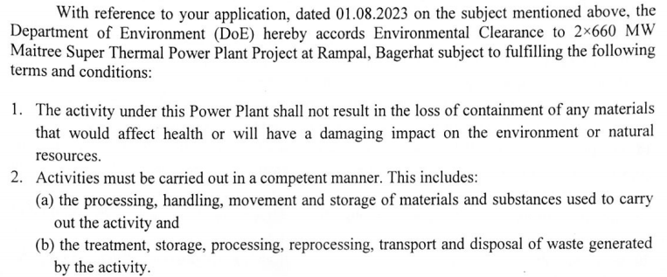

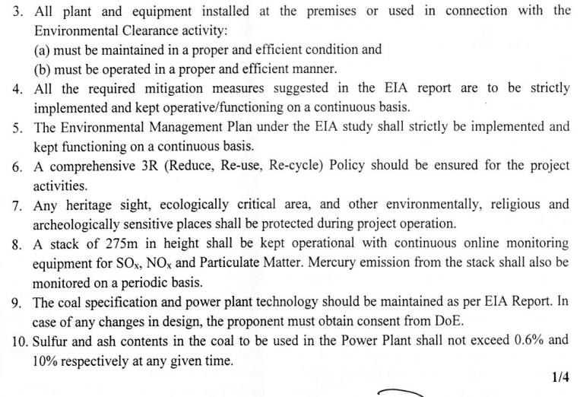
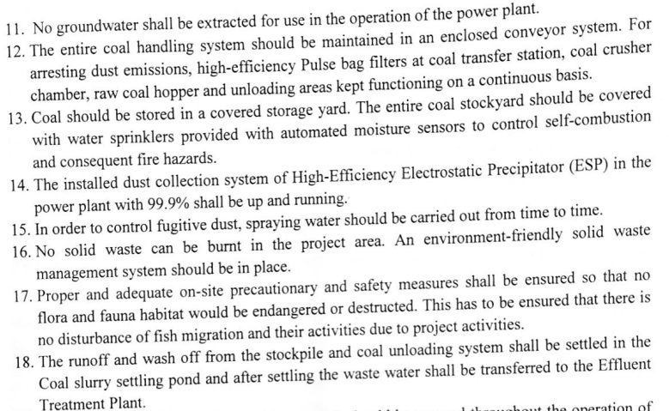
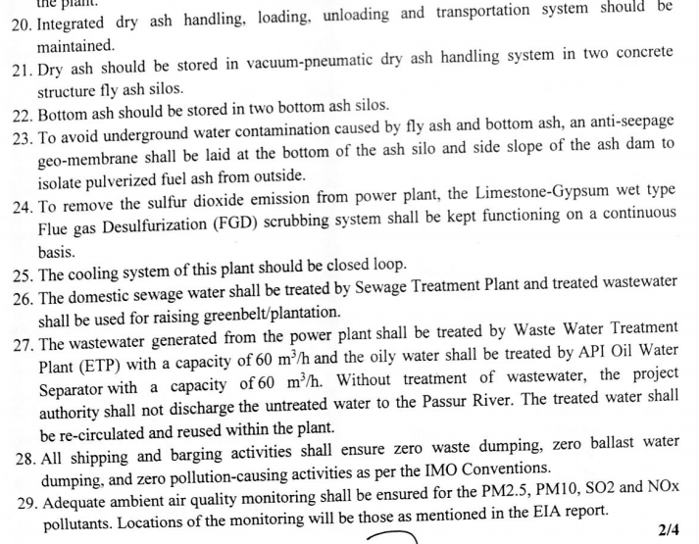
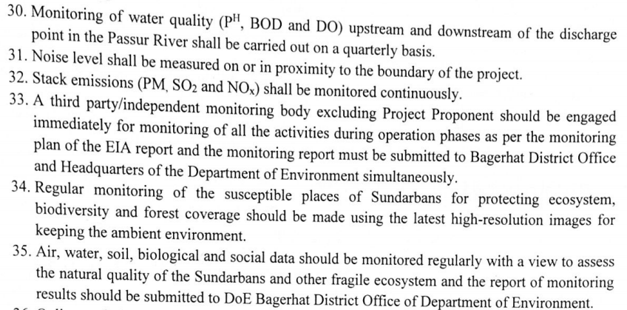
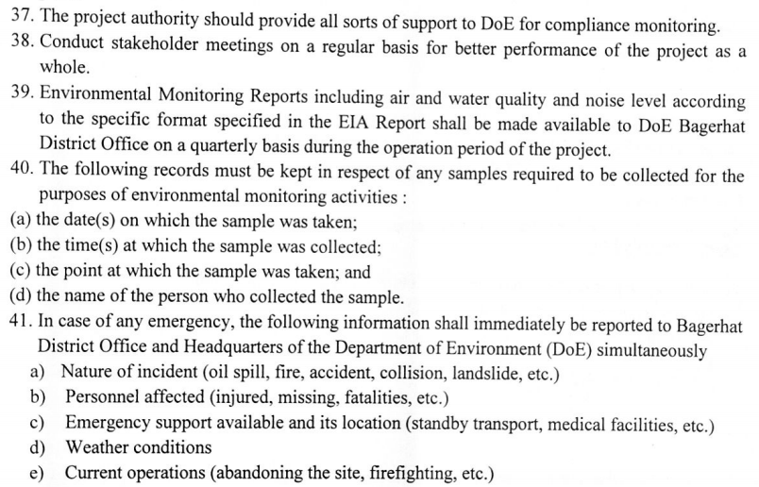
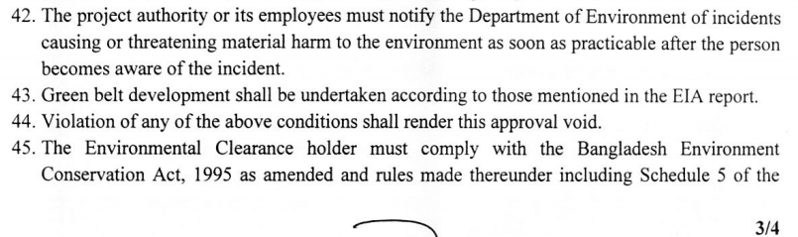
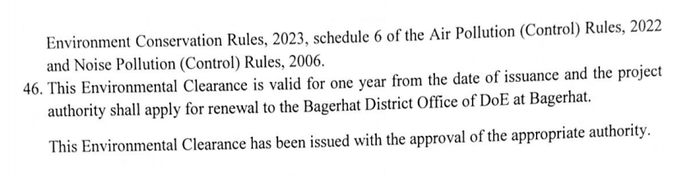

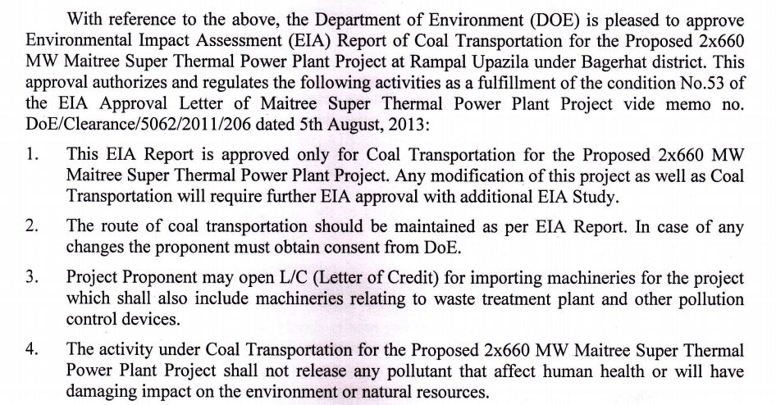
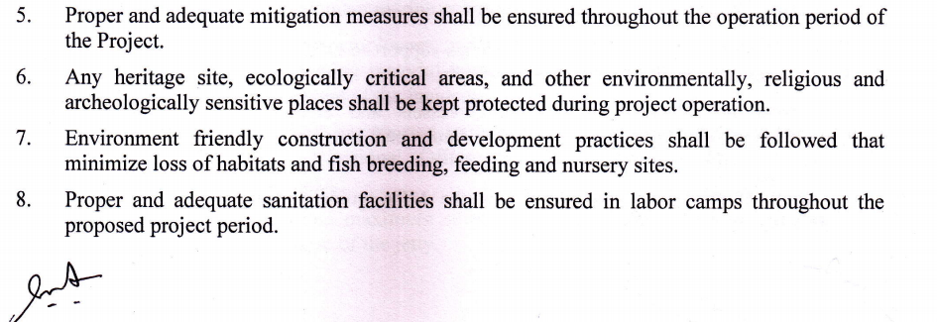

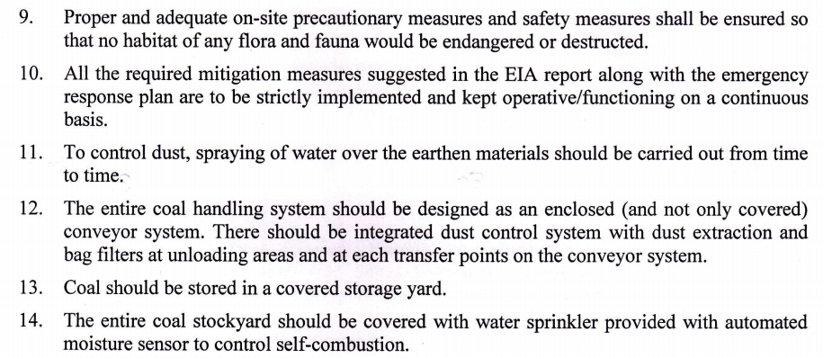

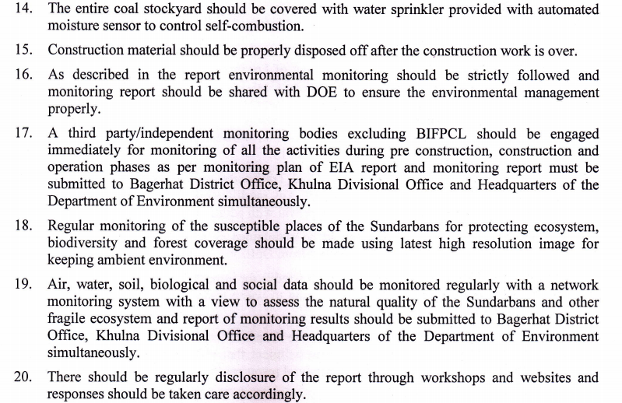

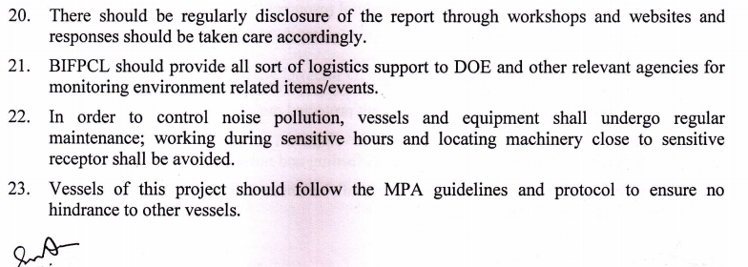

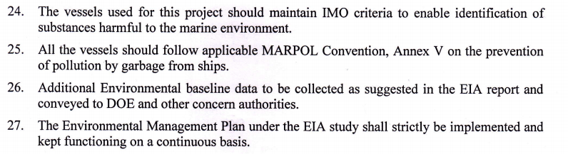

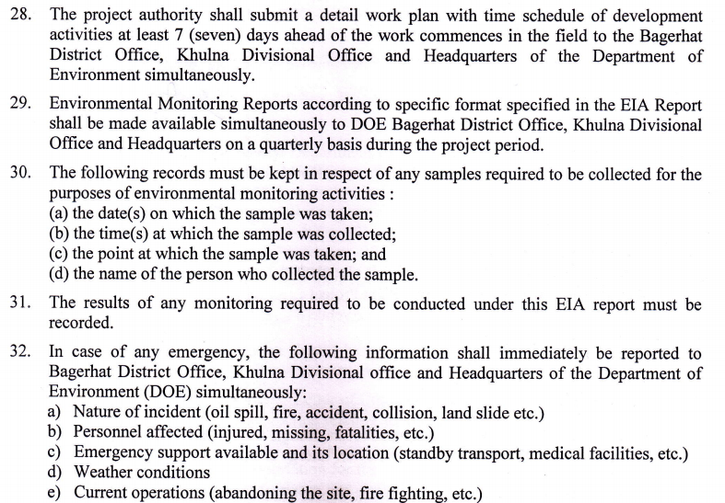
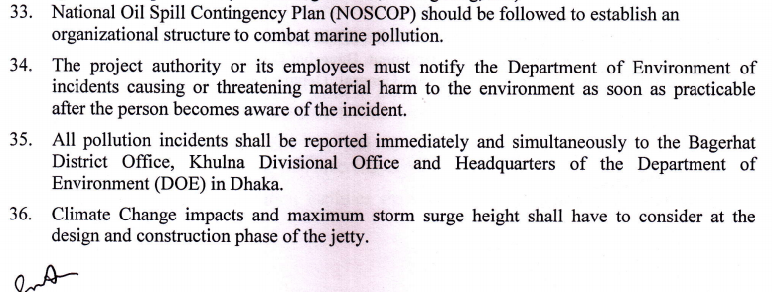
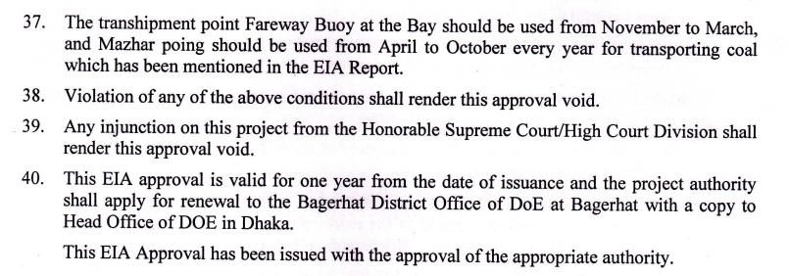

- We undertake to keep BIFPCL indemnified from any liability whatsoever arising out of our failure to comply with the guidelines of the DOE in respect of the coal transportation.
We understand and accept that our failure to comply with the EIA conditions, as applicable to us, in respect of coal transportation and supply, at any time during the currency of the Contract, shall be considered as breach of obligations and shall be liable to be dealt with as per the provisions of the Contract.

Date: …………………  Place: ……………….. | (Name of the Authorized Signatory & Designation) | …………………………………………….
 | (Name of the Company). | …………………………………………….
 | (Seal of the Company) | …………………………………………….

(Part-1)
Bidding Document No.: BIFPCL/MSTPP/COAL/2026/01

Name of Package: Procurement and Delivery of 8.0 MMT of Imported Coal at Plant Jetty (CDP) for 2x660MW Maitree Super Thermal Power Project at Rampal, District- Bagerhat, Bangladesh

(Details of Management Capabilities and Compliance with Health, Safety, and Environment Quality Standards)
To,
Chief Procurement Officer
Bangladesh-India Friendship Power Company (Pvt.) Limited (BIFPCL)
Level-17, Borak Unique Heights
117 Kazi Nazrul Islam Avenue,
Eskaton Garden
Dhaka-1000, Bangladesh

Dear Sirs,

- We hereby confirm that we do not anticipate and shall not effect any change in ownership during proposed period of execution of the Services in respect of the Contract (and in the event such a change is anticipated or proposed to be effected, the scope and effect thereof shall be defined and intimated to BIFPCL, and shall be subject to its written approval). The relevant document for same is enclosed at Annexure.............. to this Attachment-6 (Part-I).
- We, further, furnish adequate write-up on:
- Our Organization Structure for Management of Services |  | Enclosed at Annexure …… to this Attachment-3C
- Our compliance with Health, Safety, and Environment Quality Standards |  | Enclosed at Annexure …… to this Attachment-3C
Date: …………………  Place: ……………….. | (Name of the Authorized Signatory & Designation) | …………………………………………….
 | (Name of the Company). | …………………………………………….
 | (Seal of the Company) | …………………………………………….

(Part-2)
Bidding Document No.: BIFPCL/MSTPP/COAL/2026/01

Name of Package: Procurement and Delivery of 8.0 MMT of Imported Coal at Plant Jetty (CDP) for 2x660MW Maitree Super Thermal Power Project at Rampal, District- Bagerhat, Bangladesh

(Details of ongoing Assignments)
To,
Chief Procurement Officer
Bangladesh-India Friendship Power Company (Pvt.) Limited (BIFPCL)
Level-17, Borak Unique Heights
117 Kazi Nazrul Islam Avenue,
Eskaton Garden
Dhaka-1000, Bangladesh

Dear Sirs,
We, _____________, the Bidder, are presently executing the *‘Import/ Export and Supply of Dry Bulk Comodity’/ *‘Export of Coal as a Coal Mine Owner’/ *‘Transporting Dry Bulk Commodities by OGV through Sea route’ / *‘Transhiping (Onshore/ Off shore) Dry Bulk Commodities’ for the Clients and Projects, details of which are mentioned as follows:
(*Strike off whichever is not applicable)
Sl. No. | Name of Client | Name and Location of Project |  | Type of Transhipment Off shore/ On shore |  | Nature of Work | Other relevant details such as Off shore/ On shore transshipment location etc
Date: …………………  Place: ……………….. |  |  | (Name of the Authorized Signatory & Designation) |  | …………………………………………….
 |  |  | (Name of the Company). |  | …………………………………………….
 |  |  | (Seal of the Company) |  | …………………………………………….

(Part-3)
Bidding Document No.: BIFPCL/MSTPP/COAL/2026/01

Name of Package: Procurement and Delivery of 8.0 MMT of Imported Coal at Plant Jetty (CDP) for 2x660MW Maitree Super Thermal Power Project at Rampal, District- Bagerhat, Bangladesh

Any other information in terms of the IFB

Bidder may furnish any other relevant information which it deems necessary and shall enclose the same with this Attachment-7(Part-3).

Sub-Part: A2
(Financial Proposal Form and Attachments)

FINANCIAL PROPOSAL SUBMISSION LETTER

IFB No.: BIFPCL/MSTPP/COAL/8.0 MMT/1146 Date: 12.03.2026

Name of Package: Procurement and Delivery of 8.0 MMT of Imported Coal at Plant Jetty (CDP) for 2x660MW Maitree Super Thermal Power Project at Rampal, District- Bagerhat, Bangladesh

To,
Chief Procurement Officer
Bangladesh-India Friendship Power Company (Pvt.) Limited.
Level-17, Borak Unique Heights
117, Kazi Nazrul Islam Avenue,
Eskaton Garden, Dhaka-1000,
Bangladesh

Sir,

Proposal No. …………………………… Date: …………………….

- Having examined the Bidding Document(s) bearing no. BIFPCL/MSTPP/COAL/2026/01 including subsequent amendments ........................... and clarifications............................. issued thereto, if any (insert numbers), the receipt of which is hereby acknowledged, we, the undersigned, offer to provide the Services as per the Scope of Work and terms and conditions stipulated in the Bidding Document(s) for the above-named package in full conformity with the said Bidding Document(s), as per the prices quoted at Attachment-1P to this submission letter.

- Attachments to the Proposal Form (Financial):

In line with the requirement of the Bidding Document(s), we enclose herewith the following Attachments to the Bid Form:

- Attachment 1P: Price Schedule We have quoted the price for Procurement and Delivery of 8.0 MMT of Imported Coal at Plant Jetty (CDP) as per the Specifications of the Coal mentioned in the Bidding Document(s) for 2x660MW Maitree Super Thermal Power Plant at Rampal, District- Bagerhat, Bangladesh on single point responsibility basis, in accordance to the provision stipulated at ITB Clause 5.5 and as furnished in the Attachment.
- Such other Attachments as required to be submitted with the Financial Proposal in accordance with the Bidding Document(s), are attached as below:
[Bidder may specify]
2.1 Not used
2.2 We are aware and acknowledge that the Price Schedule does not generally give a full description of the Services to be performed under each line item, however, the Contract Price quoted by us is in consideration of and towards the entire scope of Services required under the Contract. We understand and acknowledge that it shall be deemed that we have read the Technical Specifications, Drawings, Conditions of Contract and other sections of the Bidding Document(s), to ascertain the full scope of work in respect of the Services and the same have been considered and included in each price item while filling in the rates and prices, with regard to the Contract Price. We agree that the rates and prices reflected in the Price Schedule shall be deemed to in respect of and inclusive of the full scope work in respect of the Services as aforesaid, including applicable overheads and profit.

2.3 We understand that in the Price Schedule, where there is discrepancy between the unit price and the total price, which is obtained by multiplying the unit price and quantity, or between sub-totals and the total price, (even in case of carry forward of prices), the unit or sub-total price shall prevail and the total price shall be corrected accordingly. We further understand that where there is discrepancy between the amounts stated in figures and the corresponding amounts stated in words, the amount stated in words shall prevail. Similarly, in case of any discrepancies between the total bid price and the summation of Schedule prices (price indicated in a Schedule indicating the total of that Schedule), the total bid price shall be corrected to reflect the actual summation of the Schedule prices.

  - We hereby agree that in case we do not indicate the price for any component(s) in the Price Schedule [Attachment-1P], in that case the price for such component(s) shall be considered included in the prices for other components for the purpose of evaluation in line with ITB Clause 5.5. We hereby also agree that in case we do not indicate price for all the components or the price components indicated are not in a manner as stipulated in ITB Clause 5.5 , the price of the components shall be worked out by BIFPCL in line with the stipulations of ITB Clause 5.5 for the purpose of price adjustment and payment during actual supply, in case of award.
- We have read the provisions of Bidding Document(s) regarding Taxes and Duties, and hereby confirm that except as otherwise specifically provided in the Bidding Document, we have included in our bid price in Attachment-1P and shall bear and pay all taxes, duties, levies and charges assessed on us and our employees by all municipal, state or national government authorities in connection with the delivery of 8.0 MMT- of Imported Coal to BIFPCL.
- We confirm that the Bid/Contract Price quoted in the Financial Proposal shall be exclusive of taxes and duties as assessed on BIFPCL and demanded by Customs Authority in Bangladesh (Custom Duty, Advance Income Tax, Value Added Tax etc.), port charges (port charges, anchorage charges, navigation charges, river dues, landing charges etc.) and any other charges payable to any Governmental Authority in performance of the Services/ Work under the Contract (excluding tug hire or purchase expenses, or mooring charges or any other port services related costs and expenses) in each case, as applicable in Bangladesh. During Execution of the contract, all such applicable taxes, duties and other charges shall be paid by the contractor directly to the concerned statutory authority. On completion of each shipment, BIFPCL will reimburse to the contractor the taxes and duties which are assessed on BIFPCL and demanded by Customs Authority in Bangladesh (Custom Duty, Advance Income Tax, Value Added Tax etc.), port charges (port charges, anchorage charges, navigation charges, river dues, landing charges etc.) in Bangladesh and exclusive of the Contract price, at actuals on submission and verification of original challan / documentary proof of such payment. Such reimbursement shall be done in Bangladesh Taka.
Tax Deduction at Source:
As per Bangladesh Income Tax Act & Rules, Tax Deduction at Source (TDS) shall be applicable on the Bidder. Bidder (s) is/ are expected to be conversant with the applicability and implication of TDS which are applicable on Bidder and consider the same in their Bid. No Claims in this regard shall be entertained by BIFPCL.
  - We confirm that except as otherwise specifically provided, our Financial Proposal includes all taxes, including applicable taxes, duties, levies and charges, as may be assessed on our sub-Contractors, both inside and outside Bangladesh.

  - We understand that notwithstanding anything stated in this clause 3 herein, the liability and payment of taxes in relation to the Services shall be as set forth in the ITB clause 5.7.
- Not Used.
- We undertake, if our bid is accepted, to commence all the necessary actions immediately upon issuance of your Letter of Intent (LOI)/ Notification of Award (NOA), and to put in place, the work and Services as are required to deliver Coal as per the Contract, on single point responsibility basis, within the timelines specified in the Bidding Document(s).
  - If our bid/ proposal is accepted, we undertake to provide Performance Securities, and other payment securities in the form and amounts and within the timelines specified in the Bidding Document(s).

- We agree to abide by this Financial Proposal for a period 180 days from the date of opening of Technical Proposal as stipulated in the Bidding Document(s), unless otherwise extended, and it shall remain binding on us and may be accepted by you at any time before the expiration of the stipulated period.
- Until a formal Contract is prepared and executed between us, this proposal, together with your written acceptance thereof in the form of your Notification of Award, shall constitute a binding contract between us.

- We understand that you are not bound to accept the lowest or any other bid you may receive.

- We, hereby, declare that only the persons or firms interested in this proposal as principals are named herein and that no other persons or firms other than those mentioned herein have any interest in this proposal or in the Contract to be entered into, if the award is made on us, and that this proposal is made without any connection with any other person, firm or partly similarly submitting a proposal, is in all respects for and in good faith, without collusion or fraud.

Dated this...................................day of….........................20...................
Thanking you, we remain,

Yours faithfully,

Date: (Signature).........................................
Place: (Printed Name) .................................
(Designation)....................................
(Common Seal) ..............................
Business Address:
Country of Incorporation (Province also to be indicated):

Fax No:
Phone No:
Mobile No:
Email ID:

IFB No.: BIFPCL/MSTP/COAL/8.0 MMT/1146 Date: 12.03.2026

Name of Package: Procurement and Delivery of 8.0 MMT of Imported Coal at Plant Jetty (CDP) for 2x660MW Maitree Super Thermal Power Project at Rampal, District- Bagerhat, Bangladesh

(Price Schedule)

Bidder's Name & Address: To,
Chief Procurement Officer
Bangladesh-India Friendship Power Company (Pvt.) Ltd.
Level-17, Borak Unique Heights
117, Kazi Nazrul Islam Avenue,
Eskaton Garden, Dhaka-1000,
Bangladesh
Dear Sirs,
1.0 We hereby quote the following as our Bid Price, considering the complete scope of work, specifications and terms and conditions of the Bidding Document(s) for the Coal, having base parameters specified at sl. no. 2.0 below and in other sections of the Bidding Document(s), for supply thereof on single point responsibility basis delivered at MSTPP Plant Jetty for 2x660MW Maitree Super Thermal Power Plant at Rampal, District- Bagerhat, Bangladesh
Sl. No. | Description | Price (USD/MT) (Unit)
1. | Bid Price for Procurement and Delivery of 8.0 MMT of Imported Coal at Plant Jetty (CDP) | …(in figures)….
1. |  | …..(in words)…..
2.0 We hereby confirm that for quoting the Bid Price in the Price Schedule, we have considered the following Coal Quality Base parameters and values thereof, besides other Coal quality parameters specified in the Bidding Document(s):
Sl. No. | Parameter for Coal quality | Basis | Base Value of Coal Quality Parameter
1. | Net Calorific Value, As Received Basis (NAR) | ARB | 5500 Kcal/Kg
2. | Ash | ADB | 12%
3. | Sulphur | ADB | 0.7%
4. | Size | - | Up to 50 mm (less than 2.0 mm: 15% max)
(ARB- As Received basis, ADB: Air Dry Basis; NAR: Net As Received)

3.0 In line with the stipulations of ITB clause 5.5, we hereby furnish break-up of the Bid Price to be quoted in terms of sl. no. 1.0 above, into the following components for price adjustment during actual supply. We understand that this break-up of price components will only be used for the purpose of price adjustment during actual supply and shall not be used for the purpose of evaluation of financial proposal.
Sl. No. | Particulars | Price Component
Sl. No. | PRICE COMPONENTS | Rate  (US$ per MT)  (In figure) | Rate  (US$ per MT)  (in word)
A | Coal FOB Price
B | Ocean Transportation:
(i) | Ocean Transportation Fixed Price*
(ii) | Ocean Transportation Freight Price*
(iii) | Ocean Transportation Bunker Price*
C | Transhipment and Barging:
(i) | Transhipment and Barging Fixed Price*
(ii) | Transhipment and Barging Bunker (HSD) Price*

(*) Refer Clause 4.0 as mentioned below.
(**) The coal insurance cost shall be adjusted for the variation in the coal FOB price as stipulated at Clause 9.0 (iv) of Section-IV.

4.0 We confirm that, we have provided separate prices under the contract for coal FOB price, ocean Transportation (Fixed, Freight and Bunker) price, Transshipment & Barging (Fixed and Bunker) price.
5.0 We hereby confirm that for the purpose of adjustment, reference indices shall be in line with the stipulations of the Bidding Document.
6.0 We confirm that the Insurance component includes all the charges as per Clause 19 of the Conditions of Contract (Section-III) of the Bidding Document.
NOTE:
- Except as otherwise specifically provided in the Bidding Document, the Bidder shall bear and pay all taxes, duties, levies and charges assessed on the Contractor and its employees by all municipal, state or national government authorities in connection with the delivery of imported coal to BIFPCL.
- The Bid/Contract Price quoted in the Financial Proposal shall be exclusive of taxes and duties as assessed on BIFPCL and demanded by Customs Authority in Bangladesh (Custom Duty, Advance Income Tax, Value Added Tax etc.), port charges (port charges, anchorage charges, navigation charges, river dues, landing charges etc.) and any other charges payable to any Governmental Authority in performance of the Services/ Work under the Contract (excluding tug hire or purchase expenses, or mooring charges or any other port services related costs and expenses) in each case, as applicable in Bangladesh, which shall be to the account of the BIFPCL.
- In respect of the Taxes and Duties as set out in ITB Clause 5.7, or otherwise under the Contract, any implication or consequence of an increase or decrease in the rates of such Taxes and Duties (including on account of any enactment, modification, amendment, replacement of Applicable Laws, any change in interpretation thereof, or otherwise), shall accrue to and be borne by the said Party who is responsible for bearing such Taxes and Duties in terms of ITB Clause 5.7 or otherwise under the Contract (as applicable).
- Any income tax e.g., Tax Deduction at Source (TDS) which is applicable as per the laws of Bangladesh during payment of the Contract price, shall be borne by the Contractor/ LC beneficiary. BIFPCL/ Bank shall deduct that TDS (if applicable) as per laws of the land and the deducted TDS shall not be reimbursed by BIFPCL.
- The quoted Contract Price is inclusive of costs towards obtaining/ maintaining licenses, permits and inspections required for the work including the cost of securing permits for materials, equipment, supplies and personnel deployed from abroad to Bangladesh, as may be necessary. and the same shall be to the account of the Bidder.

(Signature).........................................
Place: (Printed Name) .................................
(Designation).....................................
(Common Seal) .................................

E.F.T.Form
To,
Finance & Accounts Deptt.
Bangladesh-India Friendship Power Company (Pvt.) Ltd.
MSTPP, Rampal,
Bangladesh
Dear Sir,
Ref: Authorisation of all our payments through Electronic Fund Transfer System.
We hereby authorize Bangladesh-India Friendship Power Company (Pvt.) Ltd., MSTPP, Rampal, Bangladesh to make all our payments through Electronic Fund Transfer System. The details for facilitating the payments are given below:
(To be filled in Capital Letters)
- Name of the Beneficiary :………………………………………………………………………..
………………………………………………………………………………………………………………..
- Address of the Beneficiary: …………………………………………………………………….
………………………………………………………………………………………………………………..
………………………………………………………………………………………………………………..
………………………………………………………………………Postal Code……………………..
- Mobile No./Telephone No. (With STD Code):…………………………………………..
………………………………………………………………………………………………………………..
- Bank Particulars:*
- Name of the Bank………………………………………………………………………………

- Address of the Bank Branch: ………………………………………………………………
………………………………………………………………………………………………………………..
………………………………………………………………………Postal Code……………………..
- Bank’s Telephone No with STD code…………………………………………………..

- Bank’s Fax No with STD code……………………………………………………………..

- Bank Account Number………………………………………………………………………

- Bank Account Type: Saving / Current / Cash Credit/ Others- specify

- Routing number: ………………………………………………………………………………..

- SWIFT Code:……………………………………………………………………………………….

- TIN Number of Beneficiary**…………………………………………………………………
- BIN Number of Beneficiary**…………………………………………………………………
- E-Mail Address of Beneficiary for intimation regarding release of payments:

…………………………………………………………………………………………………………………..
I/We hereby declare that the particulars given above are correct and complete. If the transaction is delayed or credit is not affected at all for reasons of incomplete or incorrect information, I/We would not hold the owner responsible.

(Signature of Authorised Signatory with Date and Stamp)
*Attach a cancelled Cheque.
**Attach a copy of respective certificate.
BANK CERTIFICATION
It is certified that above mentioned beneficiary holds a bank account no………………………………………………..with our branch and the Bank Particulars mentioned above are correct.

Date:………………………. (Signature of Authorised Signatory of Bank)
Authorisation No……………………………………….

(Name and Official Stamp)

SECTION-V: BID AND CONTRACT FORMS
PART-B (Contract Forms and Proforma)

(Form-1)

Proforma for Bank Guarantee for Bid Security

[Bid Security to be issued on non-judicial stamp paper of appropriate value by a scheduled bank in Bangladesh or a foreign bank of international repute having correspondent bank located in Bangladesh, to make it enforceable, as stated under the relevant IFB Clause]

Invitation for Bid No: BIFPCL/MSTPP/COAL/8.0 MMT/1146 | Date: 12.03.2026
Bidding Document No.: BIFPCL/MSTPP/COAL/2026/01

To
Chief Procurement Officer
Bangladesh – India Friendship Power Company (Pvt.) Ltd. (“BIFPCL”)
Level 17, Borak Unique Heights, 117 Kazi Nazrul Islam Avenue,
Eskaton Garden, Dhaka – 1217, Bangladesh

BID GUARANTEE No.:

We have been informed that [insert name of Bidder¹] (hereinafter called “the Bidder”) intends to submit to you its Bid dated [insert date of Bid] (hereinafter called “the Bid”) for Procurement and Delivery of 8.0 MMT of Imported Coal at Plant Jetty (CDP) for 2x660 MW Maitree Super Thermal Power Project at Rampal, District-Bagerhat, Bangladesh under the above Invitation for Bid (hereinafter called “the IFB”).

Furthermore, we understand that, according to your conditions, Bids must be supported by a Bank Guarantee for Bid Security.

At the request of the Bidder, we [insert name of bank] hereby irrevocably and unconditionally undertake to pay you, without cavil or argument, any sum or sums not exceeding in total an amount of US Dollar [insert amount in figures and in words], upon receipt by us of your first written demand accompanied by a written statement that the Bidder is in breach of its obligation(s) under the Bid conditions, because the Bidder:

- has withdrawn its Bid after opening of Bids but within the validity of the Bid; or
- has submitted forged document in support of its qualification; or
- refused to accept unconditionally the Notification of Award (“NOA”) within the period as stated under Instructions to Bidder (“ITB”); or
- failed to furnish Performance Security within the period as stipulated in the NOA; or
- refused to sign the Contract Agreement by the time specified in the NOA; or
- did not accept the correction of the Bid price following the correction of the arithmetic errors in accordance with the ITB; or
- has been found to be engaged in corrupt, fraudulent, collusive or coercive practices while competing in the Bidding process.

This guarantee will expire:

- if the Bidder is the successful Bidder, upon our receipt of copies of the contract signed by the Bidder and the Performance Security issued to you in accordance with the ITB; or

- if the Bidder is not the successful Bidder, forty-five (45) days after the expiration of the Bidder’s Bid validity period, being [date of expiration of the Bid validity plus forty-five (45) days].

Consequently, we must receive at the above-mentioned office any demand for payment under this guarantee on or before that date.

Signature | Seal

(Form-2)

Proforma for Bank Guarantee as Contract Performance Security
[Performance Security to be issued on non-judicial stamp paper of appropriate value by schedule bank in Bangladesh or a foreign bank of international repute, having correspondent bank located in Bangladesh, to make it enforceable as stated under relevant ITB Clauses]

Notification of Award No.: | Date:
To:
Chief Procurement Officer
Bangladesh – India Friendship Power Company (Pvt.) Ltd. (BIFPCL)
Level 17, Borak Unique Heights, 117 Kazi Nazrul Islam Avenue,
Eskaton Garden, Dhaka – 1217, Bangladesh

PERFORMANCE GUARANTEE No: [insert Performance Guarantee number]

We have been informed that [name of Contractor] (hereinafter called “the Contractor”) has undertaken, pursuant to Notification of Award (NOA) No. [reference number of award notification] dated [date of NOA] (hereinafter called “the Contract”) for Procurement and Delivery of 8.0 MMT of Imported Coal at Plant Jetty (CDP) for 2x660 MW Maitree Super Thermal Power Project at Rampal, District-Bagerhat, Bangladesh under the Contract.

Furthermore, we understand that, according to your conditions, Contract must be supported by a performance guarantee.

At the request of the Contractor, we [name of bank] hereby irrevocably and unconditionally undertake to pay you, without cavil or argument, any sum or sums not exceeding in total an amount of USD …… [USD in figures and words], upon receipt by us of your first written demand accompanied by a written statement that the Contractor is in breach of its obligation(s) under the Contract conditions, without you needing to prove or show grounds or reasons for your demand of the sum specified therein.

This guarantee is valid until [date of validity of guarantee], consequently, we must receive at the above-mentioned office any demand for payment under this guarantee on or before that date.

[Signatures of authorized representatives of the bank]
Signature | Seal

(Form-3)

Bank Guarantee for Initial Payment

[Bank Guaranteed for Initial Payment to be issued on non-judicial stamp paper of appropriate value by a schedule bank in Bangladesh or a foreign bank of international repute, having correspondent bank located in Bangladesh, to make it enforceable, as stated under relevant COC Clause]

Notification of Award No.: | Date:
To:
Chief Procurement Officer
Bangladesh – India Friendship Power Company (Pvt.) Ltd. (BIFPCL)
Level 17, Borak Unique Heights, 117 Kazi Nazrul Islam Avenue,
Eskaton Garden, Dhaka – 1217, Bangladesh

INITIAL PAYMENT GUARANTEE No.:

We have been informed that [name of Contractor] (hereinafter called “the Contractor”) has undertaken, pursuant to Notification of Award (NOA) No. [reference number of award notification] dated [date of NOA] (hereinafter called “the Contract”) for Procurement and Delivery of 8.0MMT of Imported Coal at Plant Jetty (CDP) for 2x660 MW Maitree Super Thermal Power Project at Rampal, District-Bagerhat, Bangladesh under the Contract.

Furthermore, we understand that, according to your Conditions of Contract Clause 17.2.1(a)(iv), Initial Payment under the Contract must be supported by a bank guarantee to be furnished by the Contractor.

At the request of the Contractor, we [name of bank] hereby irrevocably and unconditionally undertake to pay you, without cavil or argument, any sum or sums not exceeding in total an amount of USD …… [USD in figures and words] upon receipt by us of your first written demand accompanied by a written statement that the Contractor is in breach of its obligation(s) under the Contract conditions, without you needing to prove or show grounds or reasons for your demand of the sum specified therein.

We further agree that no change, addition or other modification of the terms of the Contract to be performed, or of any of the Contract documents which may be made between BIFPCL and the Contractor, shall in any way release us from any liability under this guarantee, and we hereby waive notice of any such change, addition or modification.

This guarantee is valid until [date of validity of guarantee], consequently, we must receive at the above-mentioned office any demand for payment under this guarantee on or before that date.

[Signatures of authorized representatives of the bank]
Signature | Seal

(Form-4)

NOT APPLICABLE

Form 5

(Deed of Joint Undertaking)

(Form-5)
(ON NON-JUDICIAL STAMP PAPER OF APPROPRIATE VALUE)
FORM OF DEED OF JOINT UNDERTAKING FOR THE BIDDER AS INDIVIDUAL COMPANY TAKING STRENGTH FROM ITS *HOLDING / SUBSIDIARY / JOINT VENRURE / SUBSIDIARY OF HOLDING COMPANY TO MEET TECHNICAL CRITERIA AS PER IFB CLAUSE 5.2(i) OR 5.2(ii) OR 5.2(iii) OR AND/OR THE FINANCIAL CRITERIA MENTIONED AT IFB CLAUSE 5.3(i)

DEED OF JOINT UNDERTAKING TO BE EXECUTED BY THE BIDDER/ CONTRACTOR AND ITS *HOLDING / SUBSIDIARY / JOINT VENRURE / SUBSIDIARY (DIRECTLY OR INDIRECTLY) OF BIDDER’S HOLDING COMPANY LENDING SUPPORT FOR MEETING THE TECHNICAL CRITERIA AS PER IFB CLAUSE 5.2(i) OR 5.2(ii) OR 5.2(iii) AND /OR FINANCIAL CRITERIA AS PER IFB CLAUSE 5.3(i) FOR SUCCESSFUL PERFORMANCE OF THE CONTRACT.

The DEED OF JOINT UNDERTAKING executed on this ..... day of ...........Two thousand ..... by M/s .............................................. a Company incorporated under ................................... having its registered office at.........................................(hereinafter called the "Bidder” / “Contractor", which expression shall include its successors, administrators, executors and permitted assigns)
and
M/s .............................................. a Company incorporated under ................................... having its registered office at.........................................(hereinafter called the *"Holding Company” / * “Subsidiary Company" *“Joint Venture Company” / * “Subsidiary of Bidder’s Holding Company”, which expression shall include its successors, administrators, executors and permitted assigns),

in favour of Bangladesh-India Friendship Power Company (Pvt.) Limited, a Company incorporated under the Companies Act (Bangladesh), 1994, having its registered office at Borak Unique Heights (Level-17), 117 Kazi Nazrul Islam Avenue, Eskaton Garden, Dhaka-1000 (hereinafter called "BIFPCL", which expression shall include its successors, administrators, executors and assigns).

WHEREAS, BIFPCL invited Bids for Procurement and Delivery of 8.0 MMT of Imported Coal at Plant Jetty (CDP) for 2x660MW Maitree Super Thermal Power Project at Rampal, District-Bagerhat, Khulna Division, Bangladesh vide its Invitation for Bid (IFB) no. BIFPCL/MSTPP/COAL ..................... for delivery of Coal of quality and quantity as per the criteria stipulated in the Bidding Document(s) from designated Coal mine(s) to be approved by BIFPCL to the Plant Jetty (CDP) of 2x660 MW Maitree Super Thermal Power Project at Rampal, Bagerhat district, Bangladesh (hereinafter referred to as "the Services").

AND WHEREAS the Bidder is not independently meeting the technical criteria stipulated at IFB clause 5.2 (i) or 5.2 (ii) or 5.2 (iii) and /or Financial criteria stipulated at IFB Clause 5.3(i) of the Qualifying Requirement at clause 5.0 and is therefore relying on and borrowing from the strength from its *Holding Company / *Subsidiary Company / *Joint Venture Company / *Subsidiary of Bidder’s Holding Company, meeting the Qualifying Requirement at clause 5.4, and further, the Bidder holds a minimum of 26% of voting equity in the Joint Venture Company [to be retained if applicable].

WHEREAS the Bidder is submitting its bid/ proposal in response to the aforesaid Invitation for Bid (IFB) issued by BIFPCL and the other Bidding Documents.

AND WHEREAS in terms of the IFB, the Bidder and its *Holding Company / *Subsidiary Company / *Joint Venture Company / *Subsidiary of Bidder’s Holding Company are required to jointly execute and furnish along with the bid, an irrevocable Deed of Joint Undertaking, undertaking to and be jointly and severally liable for performance of the Services and be bound in respect of the Contract for the successful performance of Procurement and Delivery of 8.0 MMT of Imported Coal at Plant Jetty (CDP) for the 2x660MW Maitree Super Thermal Power Project at Rampal, District-Bagerhat, Khulna Division, Bangladesh, fully meeting the stipulated technical requirements, guaranteed parameters and characteristics, as per the Bidding Documents and as indicated in the bid/ proposal submitted by the Bidder, in the event, the Bid is accepted by BIFPCL, resulting into a Contract.

NOW THEREFORE, THIS DEED WITNESSETH AS UNDER:

- That in consideration of the award of the Contract by BIFPCL to the Contractor, we the Contractor and the *Holding Company / *Subsidiary Company / *Joint Venture Company /*Subsidiary of Bidder’s Holding Company, do hereby declare and undertake that we shall be jointly and severally responsible to the BIFPCL and liable for the execution and successful performance of the Services under the contract.

- We, the *Holding Company / *Subsidiary Company / *Joint Venture Company / *Subsidiary of Bidder’s Holding Company do further undertake, declare and confirm that we shall be fully responsible for imparting relevant expertise to the Contractor and training the Contractor for successful performance of the Services on sustained basis.

- In case of any breach of the Contract committed by the Contractor, we the *Holding Company / *Subsidiary Company / *Joint Venture Company / *Subsidiary of Bidder’s Holding Company do hereby undertake, declare and confirm that we shall be fully responsible for the successful performance of the Services as specified in the Contract in order to discharge the Contractor’s obligations and responsibilities stipulated in the Contract. Further, if BIFPCL sustains any loss or damage on account of any breach of the Contract or shortfall in performance of the Services or any part thereof, or any default in maintaining compliance with the EIA report, the EIA approval conditions and any other statutory orders, we the *Holding Company / *Subsidiary Company / *Joint Venture Company / *Subsidiary of Bidder’s Holding Company and the Contractor jointly and severally undertake to promptly indemnify and pay such losses/ damages caused to BIFPCL on its written demand without any demur, reservation, contest or protest in any manner whatsoever. Determination of losses/ damages shall be in line with provisions on Limitation of Liability contained in the said Contract.

- Without prejudice to the generality of the undertaking in paragraphs above, the manner of achieving the objectives set forth above shall be as follows:

  - We, the *Holding Company / *Subsidiary Company / *Joint Venture Company / *Subsidiary of Bidder’s Holding Company, shall be jointly responsible to perform successfully, all activities included in the scope including contractual obligation required to perform the Services under the contract. The responsibility and liability for the performance of the Services by the Bidder and the *Holding Company / *Subsidiary Company / *Joint Venture Company / *Subsidiary of Bidder’s Holding Company, shall be co-extensive;

  - We, the *Holding Company / *Subsidiary Company / *Joint Venture Company / *Subsidiary of Bidder’s Holding Company shall be specifically responsible for the following:

    - Provide expertise and Personnel support, as may be necessary, to the Contractor to perform the Services successfully;
    - Provide all necessary support and assistance to the Contractor in maintaining compliance with the EIA report and the EIA approval conditions, as may be necessary;
    - Extend the Health, Safety, and Environment (HSE) Quality Management System to the Contractor for performance of the Services, as may be necessary;
    - Extend Health, Safety, and Environment (HSE) Quality surveillance to the Contractor during the performance of the Services, as may be necessary;
    - Ensure that the Coal supplied to BIFPCL is as per the monthly, quarterly and yearly quantity scheduled/ finalized as per the Contract provisions and the Coal supplied to BIFPCL meets the quality parameters as per the Contract;
    - Provide necessary guidance and assistance to the Contractor in obtaining all the permissions, licences and clearances from any authority concerned for the purposes of the carrying out of the Services;
    - Ensure that the complete supply chain is smooth and free from disturbances to meet the delivery schedule as finalized as per the Contract provisions; and
    - Provide all necessary expert support and assistance to the Contractor to operate the Contract and perform the Services successfully.

- We, the Contractor and the *Holding Company / *Subsidiary Company / *Joint Venture Company / *Subsidiary of Bidder’s Holding Company do hereby undertake and confirm that our present relationship status as [_____________] shall be maintained for a lock-in period of the entire duration of the Contract. In the event that any change in relationship status becomes necessary, the same shall be informed to BIFPCL and prior written consent of BIFPCL shall be obtained before proceeding for any change in the said relationship. Any change, without obtaining BIFPCL’s written consent, in the relationship status, which forms the basis for the Bidder’s/Contractor’s meeting the Qualifying Requirement, shall be treated as breach of Contract.

- We, the Contractor and the *Holding Company / *Subsidiary Company / *Joint Venture Company / *Subsidiary of Bidder’s Holding Company do hereby undertake and confirm that this Deed of Joint Undertaking shall be initially valid till ninety (90) days beyond the duration of the Contract awarded to the Contractor. We, the Contractor and the *Holding Company / *Subsidiary Company / *Joint Venture Company / *Subsidiary of Bidder’s Holding Company do further undertake and confirm that this Deed of Joint Undertaking shall not expire nor be revoked until its validity, 90 days beyond the Term of the Contract. We further agree that this Deed of Joint Undertaking shall be without any prejudice to the various liabilities of the Contractor including Contract Performance Security as well as other obligations of the Contractor in terms of the Contract.

- Any dispute that may arise between BIFPCL and the Contractor or the *Holding Company / *Subsidiary Company / *Joint Venture Company / *Subsidiary of Bidder’s Holding Company in connection with this Deed of Joint Undertaking shall be finally settled as per the dispute resolution mechanism set out under the Contract.

This deed of undertaking shall be construed and interpreted in accordance with the Laws of England and Wales.

- That this Deed of Joint Undertaking shall be operative from the effective date of the Contract.

IN WITNESS WHEREOF, the Contractor and the *Holding Company / *Subsidiary Company / *Joint Venture Company / *Subsidiary of Bidder’s Holding Company through their authorized representatives, have executed these presents and affixed common seal of their respective companies on the day, month and year first mentioned above.

For M/s ................................
(BIDDER/ CONTRACTOR)
WITNESS:

1. ............................. ................................................
(Signature of the Authorised
Representative)
......................... Name..........................
(Official Address) Designation............................
Common Seal of the Company .............................

For M/s....................
(the *HOLDING COMPANY / *SUBSIDIARY COMPANY / *JOINT VENTURE COMPANY/
*SUBSIDIARY OF BIDDER’S HOLDING COMPANY)
WITNESS:
1. ..................................... ................................................
(Signature of the Authorised
Representative)
...................................... Name ...................................
(Official Address) Designation............................
Common Seal of the Company................................

Notes:
- Power of Attorney of the persons signing on behalf of each of the executants is to be furnished by the bidder and attached along with the signed Deed of Joint Undertaking.
- *Bidder to strike out, whichever is not applicable.

(Form-6)

NOT APPLICABLE

(Form-7)

(On Non-Judicial Stamp Paper of Appropriate Value)
FORM OF CONSORTIUM AGREEMENT
BETWEEN
M/S............................................
AND
M/S............................................
AND
M/S............................................
AND
M/S............................................

FOR SUCCESSFUL PERFORMANCE OF THE CONTRACT FOR
PROCUREMENT AND DELIVERY OF 8.0 MMT OF IMPORTED COAL AT PLANT JETTY (CDP) FOR
2x660MW MAITREE SUPER THERMAL POWER PROJECT AT RAMPAL

BIDDING DOCUMENT NO.: BIFPCL/MSTPP/COAL/2026/01

THIS Consortium Agreement executed on this....................... day of .................. Two thousand ........................... between
M/s......................................................................... a firm/ company registered/incorporated under the laws of ...................................... and having its registered office at ......................................... (hereinafter called the "Partner-1," which expression shall include its successors, executors and permitted assigns);
and
M/s ..................................................................... a firm/ company registered/incorporated under the laws of .............................................and having its registered office at .............................. ........................................ (hereinafter called the "Partner-2", which expression shall include its successors, administrators, executors and permitted assigns);and
M/s ....................................................................., a firm/ company registered/incorporated under the laws of .............................................and having its registered office at .............................. ........................................ (hereinafter called the "Partner-3", which expression shall include its successors, administrators, executors and permitted assigns);
and
M/s ....................................................................., a firm/ company registered/incorporated under the laws of .............................................and having its registered iffice at .............................. ........................................ (hereinafter called the "Partner-4", which expression shall include its successors, administrators, executors and permitted assigns),

for the purpose of submission of a bid and entering into the Contract (in case of award) against Bidding Document No. BIFPCL/MSTPP/COAL/2026/01 for ‘PROCUREMENT AND DELIVERY OF 8.0 MMT OF IMPORTED COAL AT PLANT JETTY (CDP) FOR 2x660MW MAITREE SUPER THERMAL POWER PROJECT AT RAMPAL’ of Bangladesh-India Friendship Power Company (Pvt.) Limited, a Company incorporated under the Companies Act (Bangladesh), 1994, and having its Registered Office at Borak Unique Heights (Level-17), 117 Kazi Nazrul Islam Avenue, Eskaton Garden, Dhaka-1000 (hereinafter called "BIFPCL").

WHEREAS, BIFPCL invited Bids for ‘PROCUREMENT AND DELIVERY OF 8.0 MMT OF IMPORTED COAL AT PLANT JETTY (CDP) FOR 2x660MW MAITREE SUPER THERMAL POWER PROJECT AT RAMPAL’ vide its Bidding Document No. BIFPCL/MSTPP/COAL/2026/01.

AND WHEREAS Clause No 5.1.2 of Section-I (IFB), Qualifying Requirements (QR) stipulated in Invitation for Bid (IFB) (forming part of Bidding Documents) stipulate that the Bidder can be a Consortium of maximum four (04) firms, meeting the qualifying requirements stipulated in Clause no. 5.0 of Section-I (IFB) of Bidding Document, collectively. The Consortium is also required to necessarily identify one of the partners as the Lead Partner.
WHEREAS sub-clause (v) of clause 5.4 of Qualifying Requirements Section-I (IFB) further stipulates that in case the Bidder is acting through a Consortium, the Bidder shall provide along with the bid, a Consortium Agreement as per the format applicable, inter alia providing that each Consortium partner is jointly and severally liable to BIFPCL for due performance of all contractual obligations towards the Services. The Consortium Agreement shall be submitted along with the bid, failing which the Bidder shall be disqualified and its bid shall be rejected.
AND WHEREAS M/S……………(Partner-1/ Lead Partner of Consortium) and M/S…………… (Partner-2 of Consortium) and M/S…………… (Partner-3 of Consortium) and M/S…………… (Partner-4 of Consortium), collectively meeting any one of the technical criteria stipulated at Clause *5.2 (i) or *5.2 (ii) or *5.2 (iii) and financial criteria mentioned at Clause 5.3. Each partner of the consortium meets at least 25% of any one of the technical criteria requirement stipulated at Clause *5.2 (i) or *5.2 (ii) or *5.2 (iii) or *5.2 (iv), or at least 25% of the Financial Criteria mentioned at Clause 5.3(i). The lead partner meets on its own at least 51% of the Technical Criteria mentioned at Clause *5.2 (i) or *5.2 (ii) or *5.2 (iii), and at least 20% of Financial Criteria mentioned at Clause 5.3(i).
AND WHEREAS the bid has been submitted to BIFPCL vide proposal No. …………………………..dated ……………….., including on the basis of the Consortium Agreement being these presents in accordance with the requirement of the Qualifying Requirements under the IFB, and have have been signed by each partner of the Consortium and and thereon submitted to BIFPCL.
NOW THEREFORE, THIS AGREEMENT WITNESSTH AS UNDER:
- That in consideration of the Award of the Contract by BIFPCL to the Consortium, we the partners of the Consortium and as signatories to the Consortium Agreement, do hereby agree that Partner-1 (M/s...........................................................), shall act as the Lead Partner for the Consortium, and further declare, confirm and undertake that that we, being each Consortium Partner, shall, jointly and severally be bound to BIFPCL for the execution of the Contract and performance of the Services, in accordance with the terms of the Contract and such co-extensive liability shall extend to the performance of all technical, legal and contractual obligations set out under the Contract and the Bidding Documents. Further, the Lead Partner shall be responsible for (and be authorized towards) incurring liabilities, binding the Consortium, and receiving payments from BIFPCL on behalf of the Consortium, and receiving instructions for and on behalf of the Consortium and communications regarding the implementation of the Contract, shall be undertaken exclusively / by the Lead Partner, who shall be required to make necessary communications regarding the same to other partners of the Consortium.
  - We, the partners of the Consortium confirm that in case of award of Contract, we shall execute and perform the Services, for which we have the requisite experience and qualifications, collectively to perform in respect of the Contract.
  - In case of any breach of the said Contract by any of the Consortium Partners, the other Partners hereby agree and undertake to be fully responsible for the successful performance of the Services in accordance with the terms of the Contract.
2. Notwithstanding anything contained herein, Partner-2 and *Partner-3 and *Partner-4 do hereby undertake, declare and confirm that it shall be fully responsible for the successful performance of the contract and undertakes to carry out all the obligations and responsibilities under this Consortium Agreement in order to discharge the obligations and responsibilities stipulated in the contract. Further, in the event BIFPCL sustains any loss or damage on account of any breach of the Contract at the behest of the Consortium, we, the Consortium Partners, undertake to jointly and severally, and promptly indemnify, and pay such loss/damages, caused to BIFPCL on its written demand, without any demur, reservation, contest or protest in any manner whatsoever. This is without prejudice to any rights of BIFPCL against the Lead Partner under the Contract and / or guarantees issued in its favour. We agree that BIFPCL shall be free to proceed against any or all the Consortium Partners in the event of a breach or failure to perform in respect of the Contract and it shall not be necessary or obligatory for BIFPCL to proceed against the Lead Partner/ Partner-1 to these presents before proceeding against Partner-2 and/or *Partner-3 and/or *Partner-4.

We also confirm that any extension of time or relaxation given by BIFPCL to the Consortium or any Consortium Partner shall not prejudice any rights of BIFPCL under this Consortium Agreement to proceed against us.

3. The financial liability of each of the partners of the Consortium, to BIFPCL with respect to any and all claims arising out of the non-performance of the terms of Contract shall, not be limited in any way so as to restrict or limit the individual liabilities of each of the partners.

4. In case of an award of Contract, we the partners to the Consortium do hereby agree and undertake to furnish the Contract Performance Security from a qualified Bank in favour of BIFPCL for the value as stipulated under the Contract, in the name of all the Consortium Partners.

5. It is expressly understood and agreed between the partners to this Agreement that the performance-linked responsibilities and obligations of each of the Partners shall be delineated, only for the purposes of understading of specific performance, in Appendix-1 to this Agreement. It is therfore expressly agreed that the delineation and splitting of responsibilities and obligations, shall not in any way act as a limit to the joint and several responsibilities of the Partners under the Contract.

- We, the Consortium Partners agree that this Agreement shall be irrevocable and shall form an integral part of the Contract. We further agree that this Agreement shall continue to be enforceable until the successful completion of Contract, and. or until the Consortium stands discharged by BIFPCL in this regard. We further agree and acknowledge that notwithstanding the expiry or termination of this Agreement, the various obligations and liabilities of each of the Consortium Partners, as envisaged in terms of the Contract and this Agreement, shall survive the expiry/ termination of this Agreement.

- This Agreement shall be construed and interpreted in accordance with the Laws of England and Wales.

- This Agreement shall be effective from the date hereof.

IN WITNESS WHEREOF, each of the Consortium partners through their authorised representatives have executed these presents and affixed common seal company on the day, month and year first mentioned above.

For M/s.........................................................
Witness:(Consortium Partner-1)/ Lead Partner

1. Common Seal of
M/s.................... .................................................................
has been affixed in my / our (Signature of the authorised
Presence pursuant to Board of representative)
Directors’ Resolution dated… Name.......................................................
Signature............................... Designation.............................................
Name............................... Common Seal of the Company.......................
Designation...........................

For M/s.........................................................
Witness: (Consortium Partner-2)

1. Common Seal of
M/s.................... ...............................................................
has been affixed in my / our (Signature of the authorised
Presence pursuant to Board of representative)
Directors’ Resolution dated….. Name......................................................
Signature............................... Designation.............................................
Name............................... Common Seal of the Company.......................
Designation...........................

For M/s.........................................................
Witness: (Consortium Partner-3)

1. Common Seal of
M/s.................... ...............................................................
has been affixed in my / our (Signature of the authorised
Presence pursuant to Board of representative)
Directors’ Resolution dated….. Name......................................................
Signature............................... Designation.............................................
Name............................... Common Seal of the Company.......................
Designation...........................

For M/s.........................................................
Witness: (Consortium Partner-4)

1. Common Seal of
M/s.................... ...............................................................
has been affixed in my / our (Signature of the authorised
Presence pursuant to Board of representative)
Directors’ Resolution dated….. Name......................................................
Signature............................... Designation.............................................
Name............................... Common Seal of the Company.......................
Designation...........................

[Appendix – 1 to be separately provided and annexed by the Bidder]

(Form-8)

DRAFT FORM OF NOTIFICATION OF AWARD

Ref. No.: Date:
..........(Contractor's Name & Address)............
.............................................................................
.............................................................................
.............................................................................
Attn.: Mr. ..........................................
Sub: Notification of Award of Procurement and Delivery of 8.0 MMT of Imported Coal at Plant Jetty (CDP) for 2x660 MW Maitree Super Thermal Power Plant Project at Rampal, District- Bagerhat, Khulna division, Bangladesh as per Bidding Document No.BIFPCL/MSTPP/COAL/2026/01.
Dear Sir,
1.0 This has reference to the following:
(i) Our Invitation for Bid (IFB) No. .....................................dated.................
(ii) Bidding Documents for the subject package issued to you vide our letter no. .................................. dated ............................. comprising the following:

.......................(List out all the Sections/Volumes of the Bidding Document along with Tender Drawings etc. as issued to the Bidder)..........
Errata/Amendment No........................ to.................... (Name of Section/Volume of the Bidding Document to which errata/amendment pertains) .................issued to you vide our letter no. ................ dated .............................
(Applicable only if any errata/amendment to the Bidding Document have been issued subsequently)
(iii) Clarifications furnished to you on the Bidding Document vide our letter no.................... dated ............................... based on the query raised by prospective bidders. (Use as applicable)
(Applicable only if any clarification to the Bidding Document has been issued subsequently)
(INCLUDE AS FURTHER SUB-PARA ANY OTHER CORRESPONDENCE MADE TO THE BIDDER AFTER ISSUANCE OF BIDDING DOCUMENT UP TO THE DATE OF TECHNICAL PROPOSAL OPENING)
(iv) Your Bid for the subject package submitted vide your letter no. ..................... dated...................... and its modification vide letter no. ...................................... dated .......................... (delete if not applicable).

(v) Our fax message/letter No. ............................................. dated........................... regarding extension of validity of bid and that of the bank guarantee towards Bid Security.
(Applicable only if any extension has been sought subsequently)
(INCLUDE AS FURTHER SUB-PARA ANY OTHER CORRESPONDENCE MADE TO OR BY THE BIDDER AFTER TECHNICAL PROPOSAL OPENING)
(vi) Our fax message/letter no. .................................. dated...................................... inviting you for post bid discussions.
(vii) Post bid discussions and meetings we had with you from .................................... to ....................................... resulting into the following minutes of meeting enclosed herein with this Notification of Award:
(a) Minutes of meeting regarding Commercial issues (APPENDIX - ….......)
(b) Minutes of meeting on technical issues (APPENDIX - ...................)
(c) Minutes of meeting regarding Work Schedule (APPENDIX - ................)
(d) Minutes of meeting regarding Quality Assurance aspects (APPENDIX-………)
2.0 This is to inform you and confirm that having accepted your Bid submitted vide letter no. ........................ dated .......................................... and its modification vide letter no................................ dated (delete if not applicable) read in conjunction with all the specifications, terms & conditions of the Bidding Document, your subsequent letters (use if relevant) and agreed minutes of meeting referred to in para 1.0 above, BIFPCL hereby award the Contract for the work of ............................(Indicate brief Scope of Services) ...................................... of......................................... (Name of Contract) .....................................for (Name of Project) ......................................... as per Bidding Document no.: ......................................, in your favour.
3.0 The Contract Price for the entire Scope of Services under the Contract shall be .............(Specify the amount and currency)................
4.0 You shall prepare and finalize the Contract Document for signing of the formal Contract Agreement and shall enter into the Contract Agreement with us, as per the proforma enclosed with the Bidding Document, on non-judicial stamp paper of appropriate value within ……… days from the date of this Notification of Award.
5.0 The provisions and stipulations, including the obligations and liabilities of the Contractor, as set out in the Bidding Documents, especially under Section-III (Conditions of Contract) of the Bidding Documents, shall mutatis mutandis apply to and in respect of this Notification of Award.
6.0 Until the formal Contract Agreement is signed, this Notification of Award shall constitute a legally binding and enforceable Contract.
7.0 We request you to submit acceptance of this Notification of Award by furnishing a copy thereof duly countersigned and stamped on each page, including all the enclosed appendices, by the authorized signatory of the Contractor, as a proof of your acknowledgement and confirmation.

You are required to take the necessary action to prepare for commencement of the Services and confirm action taken in this regard to BIFPCL.
Yours faithfully,
for and on behalf of
Bangladesh-India Friendship Power Company (Pvt.) Ltd.
(Authorised Signatory)
Encl.: As above.

(Form-9)

DRAFT FORM OF CONTRACT AGREEMENT
(To be executed on a Stamp Paper of appropriate value as per the applicable law in Bangladesh)

This Contract is made at Dhaka on ________ [day] ______ [month] _____[year] by and between

Bangladesh-India Friendship Power Company (Pvt.) Limited (a Company incorporated under the Companies Act 1994 of Bangladesh) having its registered office at ________ (hereinafter referred to as “BIFPCL”, which expression shall, unless excluded by or repugnant to the context, be deemed to include its successors and permitted assigns) of the FIRST PART
AND
_________________[Contractor’s name] (a Company incorporated under the ___________/ Consortium constituted in terms of the Consortium Agreement dated ___________) having its registered office at __________[Address] (hereinafter referred to as “Contractor”, which expression shall, unless excluded by or repugnant to the context, be deemed to include its successors and permitted assigns) of the SECOND PART.
(Both BIFPCL and the Contractor shall be individually referred to as a “Party” and collectively referred to as the “Parties”)
WHEREAS
- BIFPCL invited bids vide Invitation of Bid (IFB) no. _______ dated ________ for Procurement of 8.0 MMT of Imported Coal to be delivered at Plant Jetty (CDP) for 2x660 MW Maitree Super Thermal Power Plant Project at Rampal (hereinafter referred to as the “Tender”), wherein BIFPCL had prescribed the technical and financial terms and conditions in the Bidding Document(s) as issued by it for the subject Tender.
- _________ (the Contractor, as the successful Bidder) submitted its Bid in the form of its Technical Proposal and Financial Proposal, for undertaking the Services as prescribed in respect of the subject Tender in the Bidding Documents. Upon consideration and evaluation of the successful Bidder’s proposal, BIFPCL accepted the proposal of the Contractor and in furtherance thereof, issued the Notification of Award (hereinafter referred to as the “NOA”) in favour of the Contractor requiring, inter alia, the signing of this Contract Agreement within …….days of the date of issuance of the NOA, for the purpose of performance of the Services, including the transportation, transhipment and delivery of the Coal at the CDP.
- The Contractor’s proposal (both Technical and Financial) submitted in vide the Bid forms/ attachments, including the technical and financial warranties and representations, and commitments and undertakings, made therein and in terms thereof, constitute the basis for selection of successful Bidder as the Contractor for the subject Tender.
- The Contractor having been awarded this Contract by BIFPCL shall remain solely liable, responsible and accountable to BIFPCL for successful performance of the entire Contract and provisioning of the Services as required in terms thereof.
The provisions and stipulations, including the obligations and liabilities of the Contractor, as set out in the Bidding Documents, especially under Section-III (Conditions of Contract) of the Bidding Documents, shall mutatis mutandis apply to and in respect of this Contract Agreement.
DOCUMENTS CONSTITUTING THE CONTRACT
The documents forming the Contract (as set forth hereinafter) are to be taken as complimentary to one another and therefore read harmoniously. In case of any ambiguity, or discrepancy or inconsistency between the provisions of the various sections of the documents listed herein below, the order of precedence (in decreasing order of precedence) to be observed and maintained while constructing and interpreting the terms of Services shall be as follows:
- This Contract Agreement duly executed on non-judicial stamp paper;
- NOA duly accepted by the Contractor;
- Addenda, errata, amendments, and clarifications issued by BIFPCL with respect to the Bidding Documents;
- The Conditions of Contract (Section-III) of the Bidding Document;
- Technical Specification (Section-IV) of the Bidding Document;
- Other Sections comprising the Bidding Document;
- Financial Proposal of the Contractor; and
- Technical Proposal of the Contractor.
Without prejudice to the foregoing, any ambiguity or discrepancy or inconsistency between the provisions of all or any of the aforesaid documents constituting the Contract may be clarified/resolved by BIFPCL, who shall then instruct the Contractor in accordance thereof, failing which the stipulation contained in the stricter condition amongst the inconsistent provisions shall apply.
The Contract, once signed, shall supersede all prior correspondence between the Parties, to the extent of inconsistency or repugnancy to the terms and conditions contained in the Contract. Any modification of this Contract shall be effected only by a written instrument signed by the authorized representative of the Parties.

NOW, THEREFORE, in consideration of the Agreement and covenants hereinafter set out, and intending to be legally bound hereby, the Parties hereto covenant and agree with each other
Signed this day as above mentioned by both the Parties:
For BIFPCL | For ………………  (Name of Contractor)
Signature  Name:  (block letters)  Designation:  Address:  Telephone:  Fax:  Email: | Signature  Name:  (block letters)  Designation:  Address:  Telephone:  Fax:  Email:
Witness 1 | Witness 1
a) Signature  b) Name  (block letters)  c) Address & Occupation | a) Signature  b) Name  (block letters)  c) Address & Occupation
Witness 2 | Witness 2
a) Signature  b) Name  (block letters)  c) Address & Occupation | a) Signature  b) Name  (block letters)  c) Address & Occupation

